

Boeing Autonomous
Final CAD Deliverable
SolidWorks Drawing Files
By: Elise C., Selina C., Jacob K., Marek L., Desirae M., Natasa P., Lily Q.
Brakes
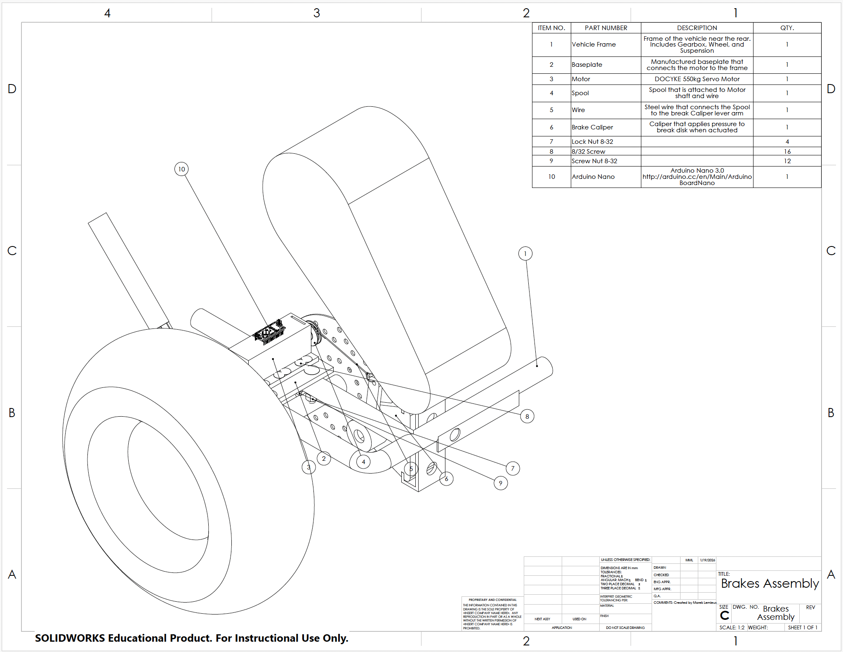
Figure 1: Previous Brakes Assembly
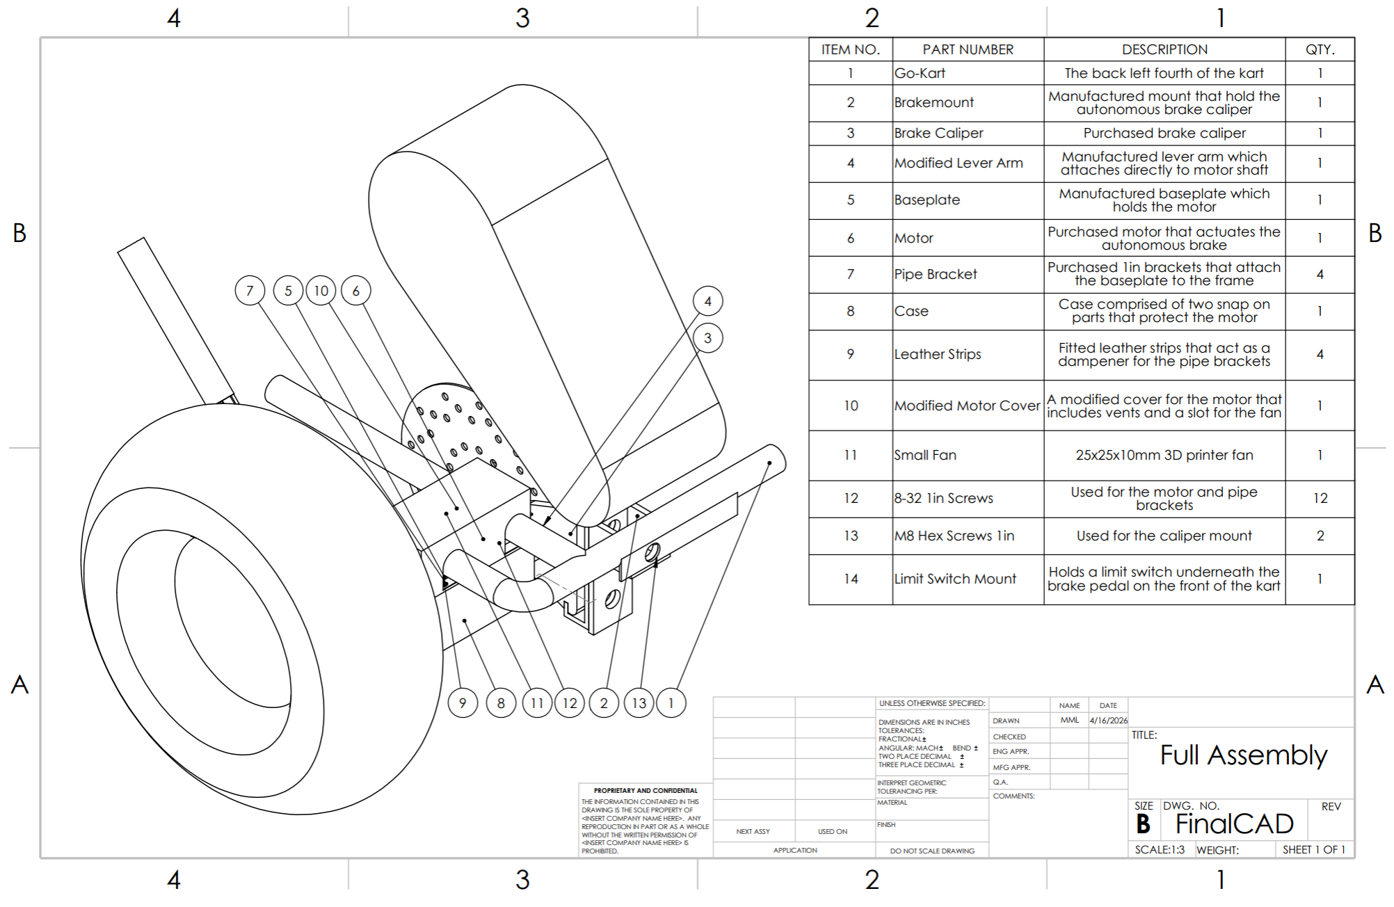
Figure 2: Updated Brakes Assembly
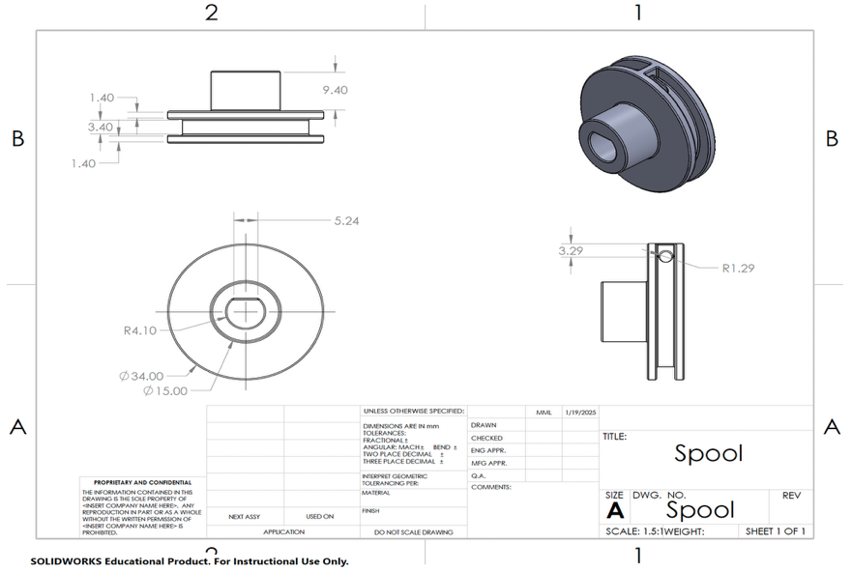
Figure 3: Old Brakes Spool

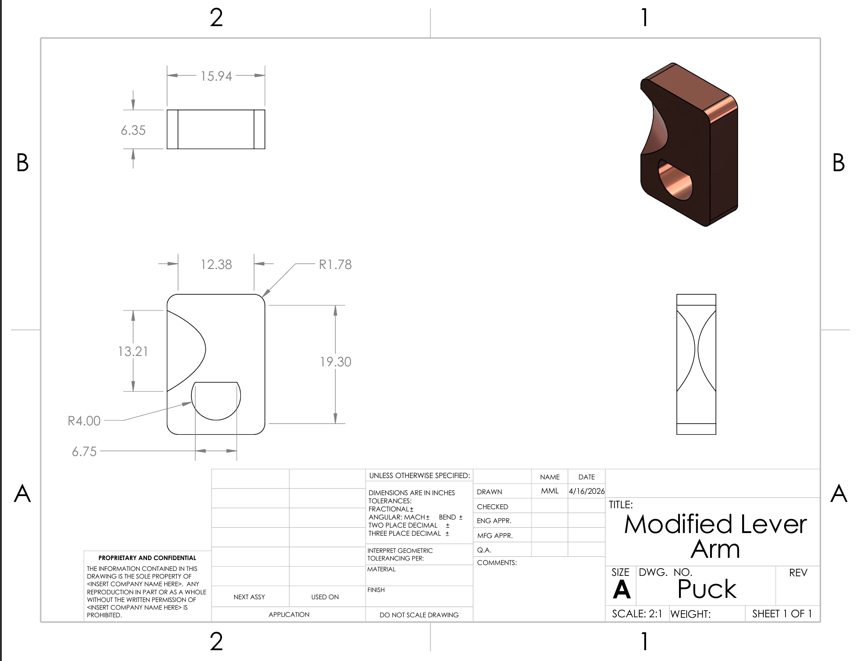
Figure 4: Brakes Modified Lever Arm

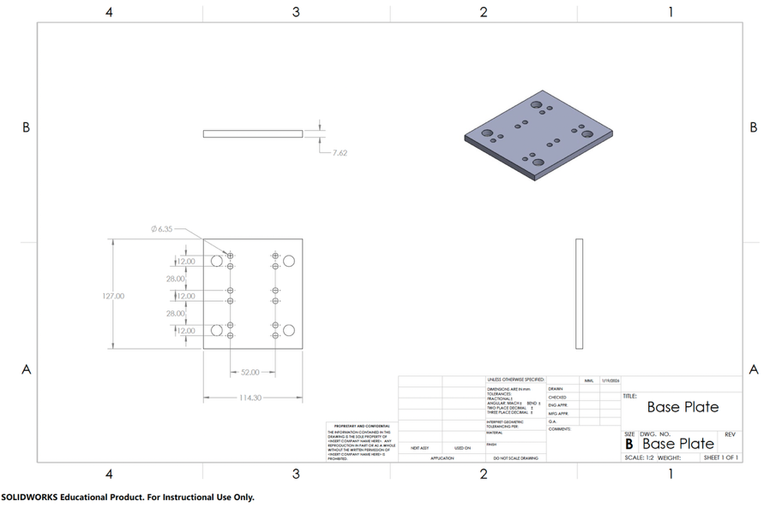
Figure 5: Old Brakes Base Plate
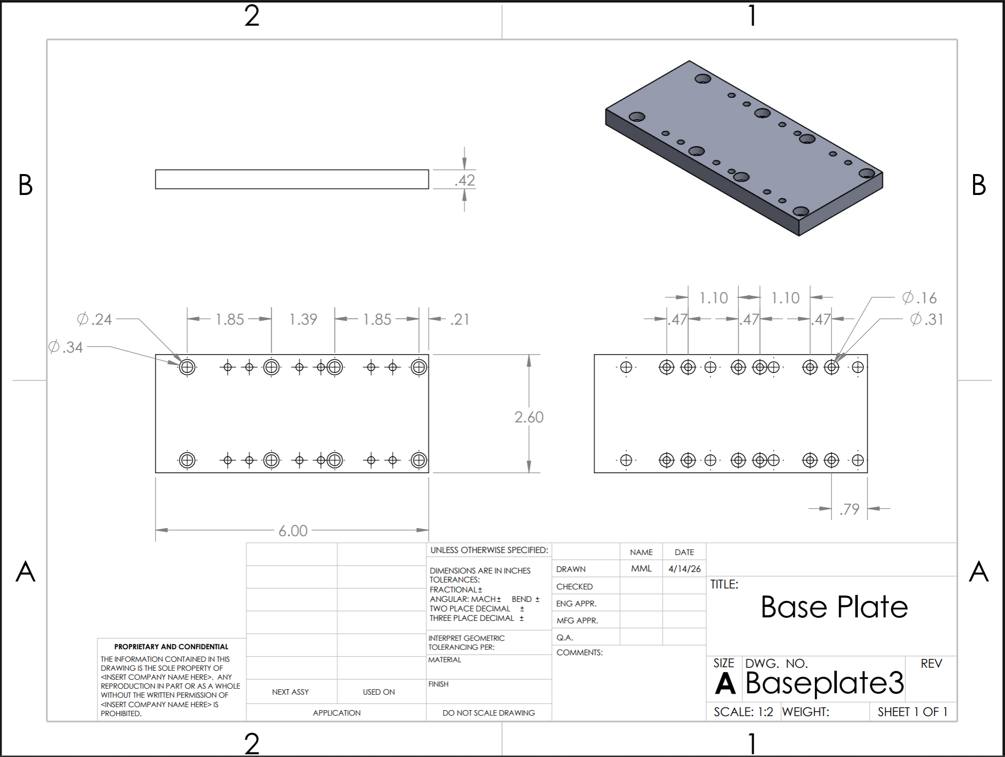
Figure 6: Updated Base Plate
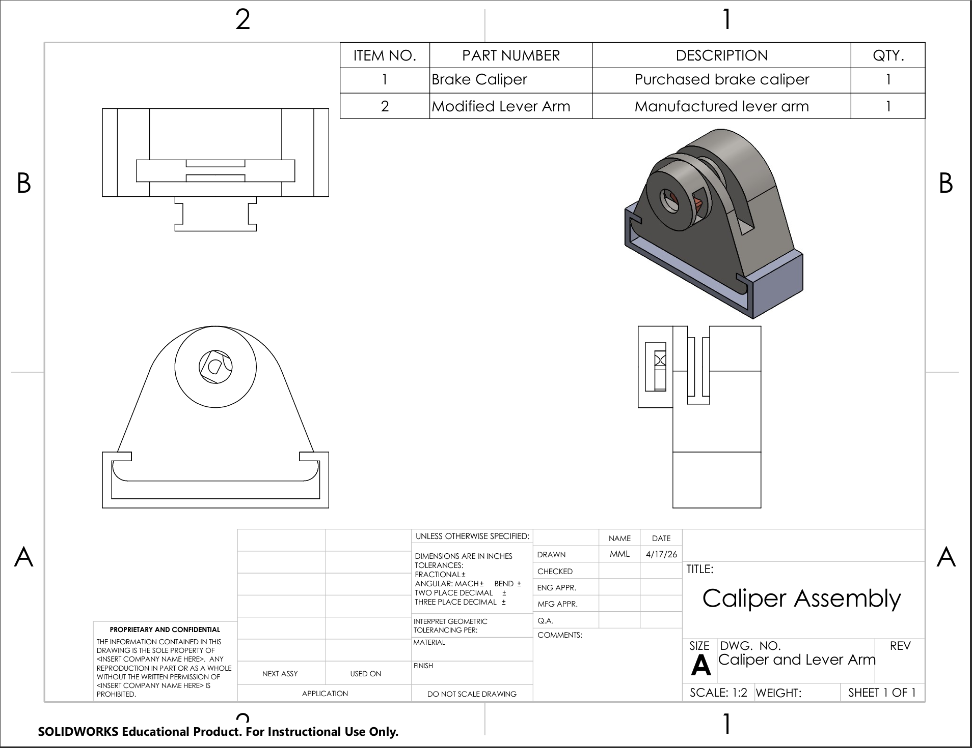
Figure 7: Brake Caliper Sub-Assembly
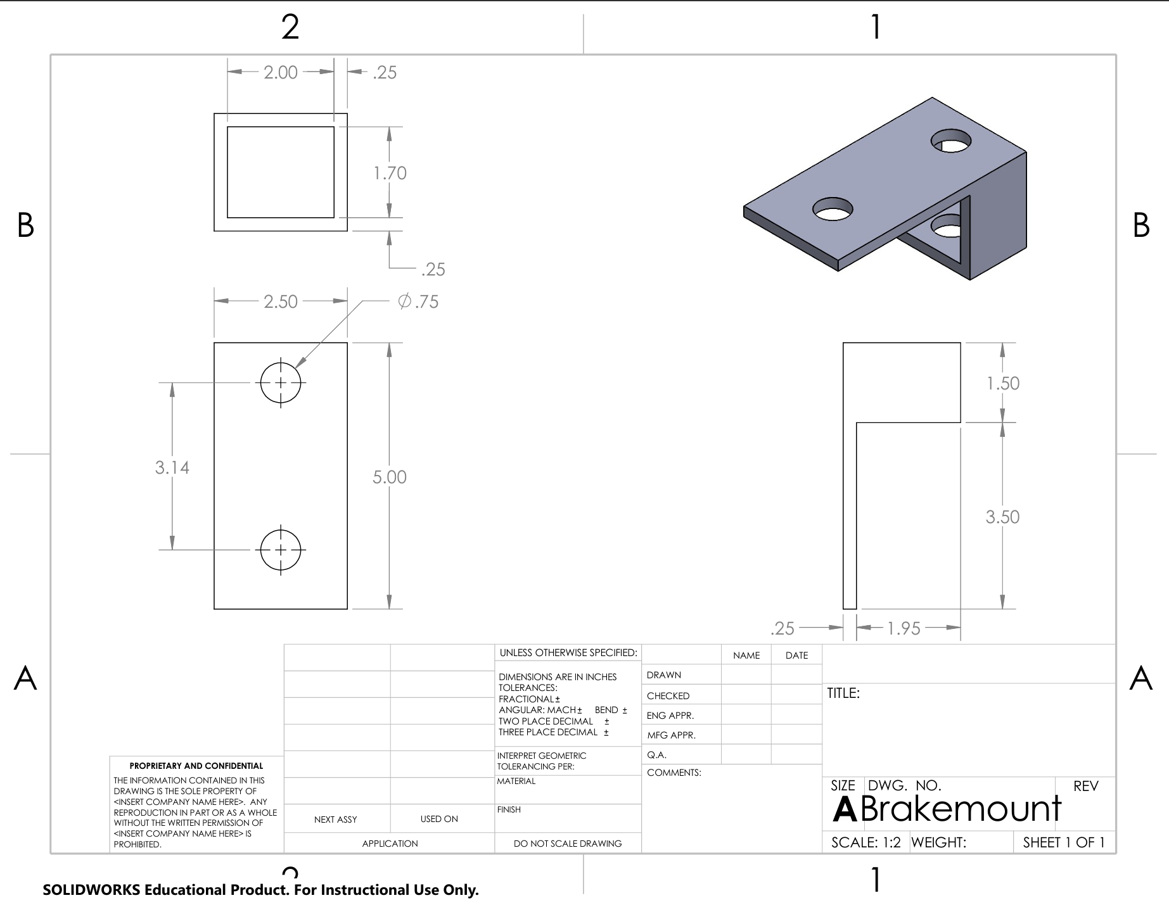
Figure 8: Brake Caliper Mount
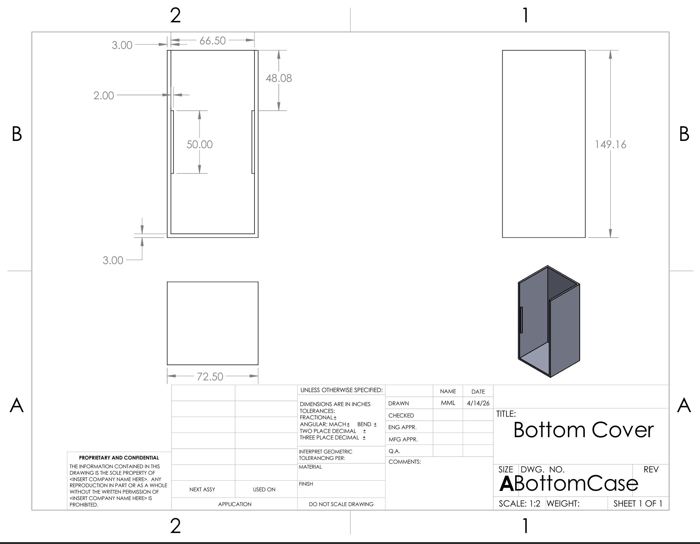
Figure 9: Bottom Motor Cover
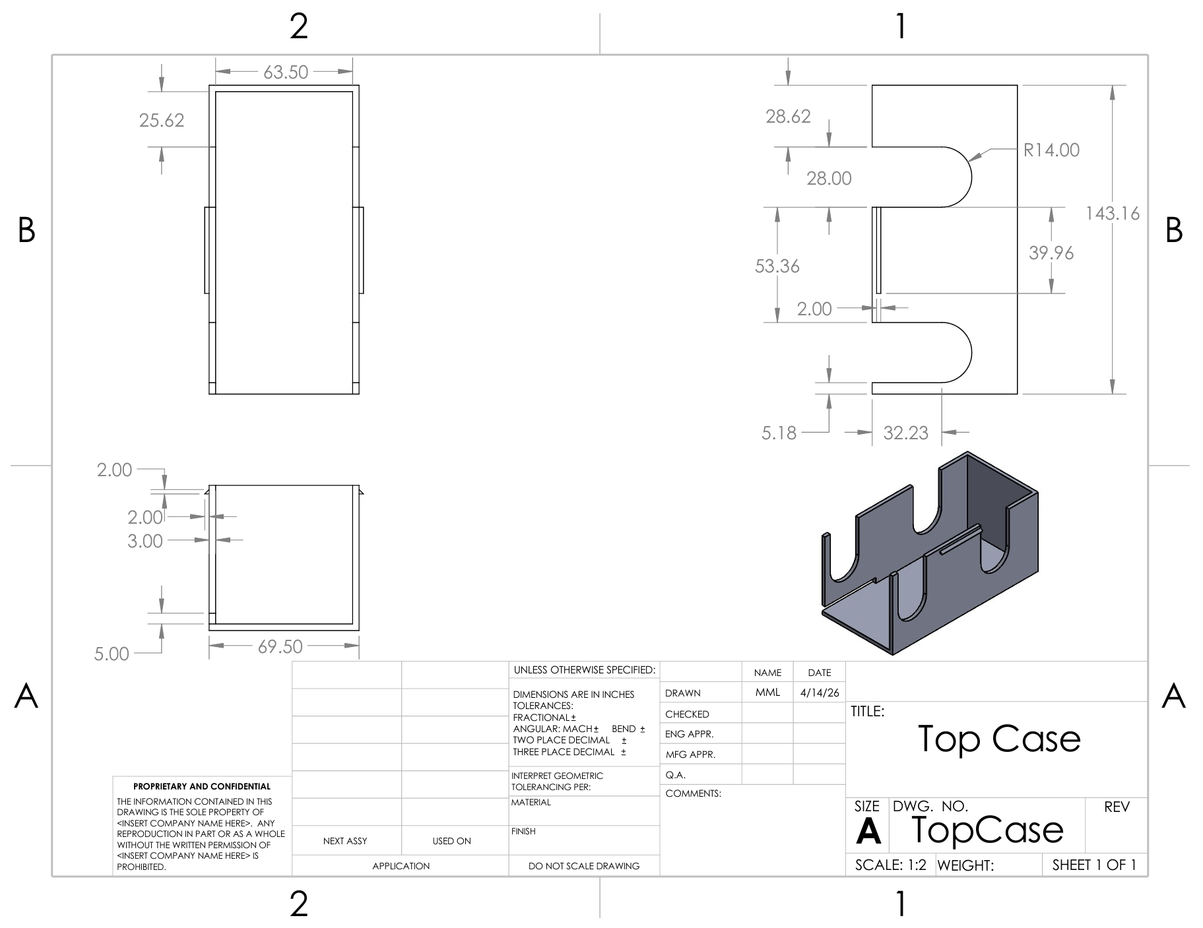
Figure 10: Top Motor Cover
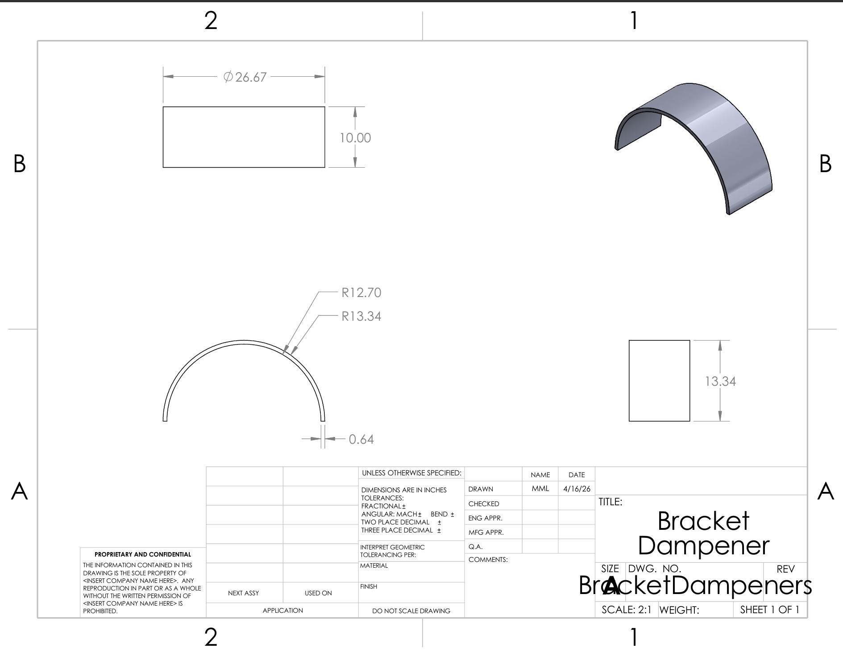
Figure 11: Pipe Bracket Dampener
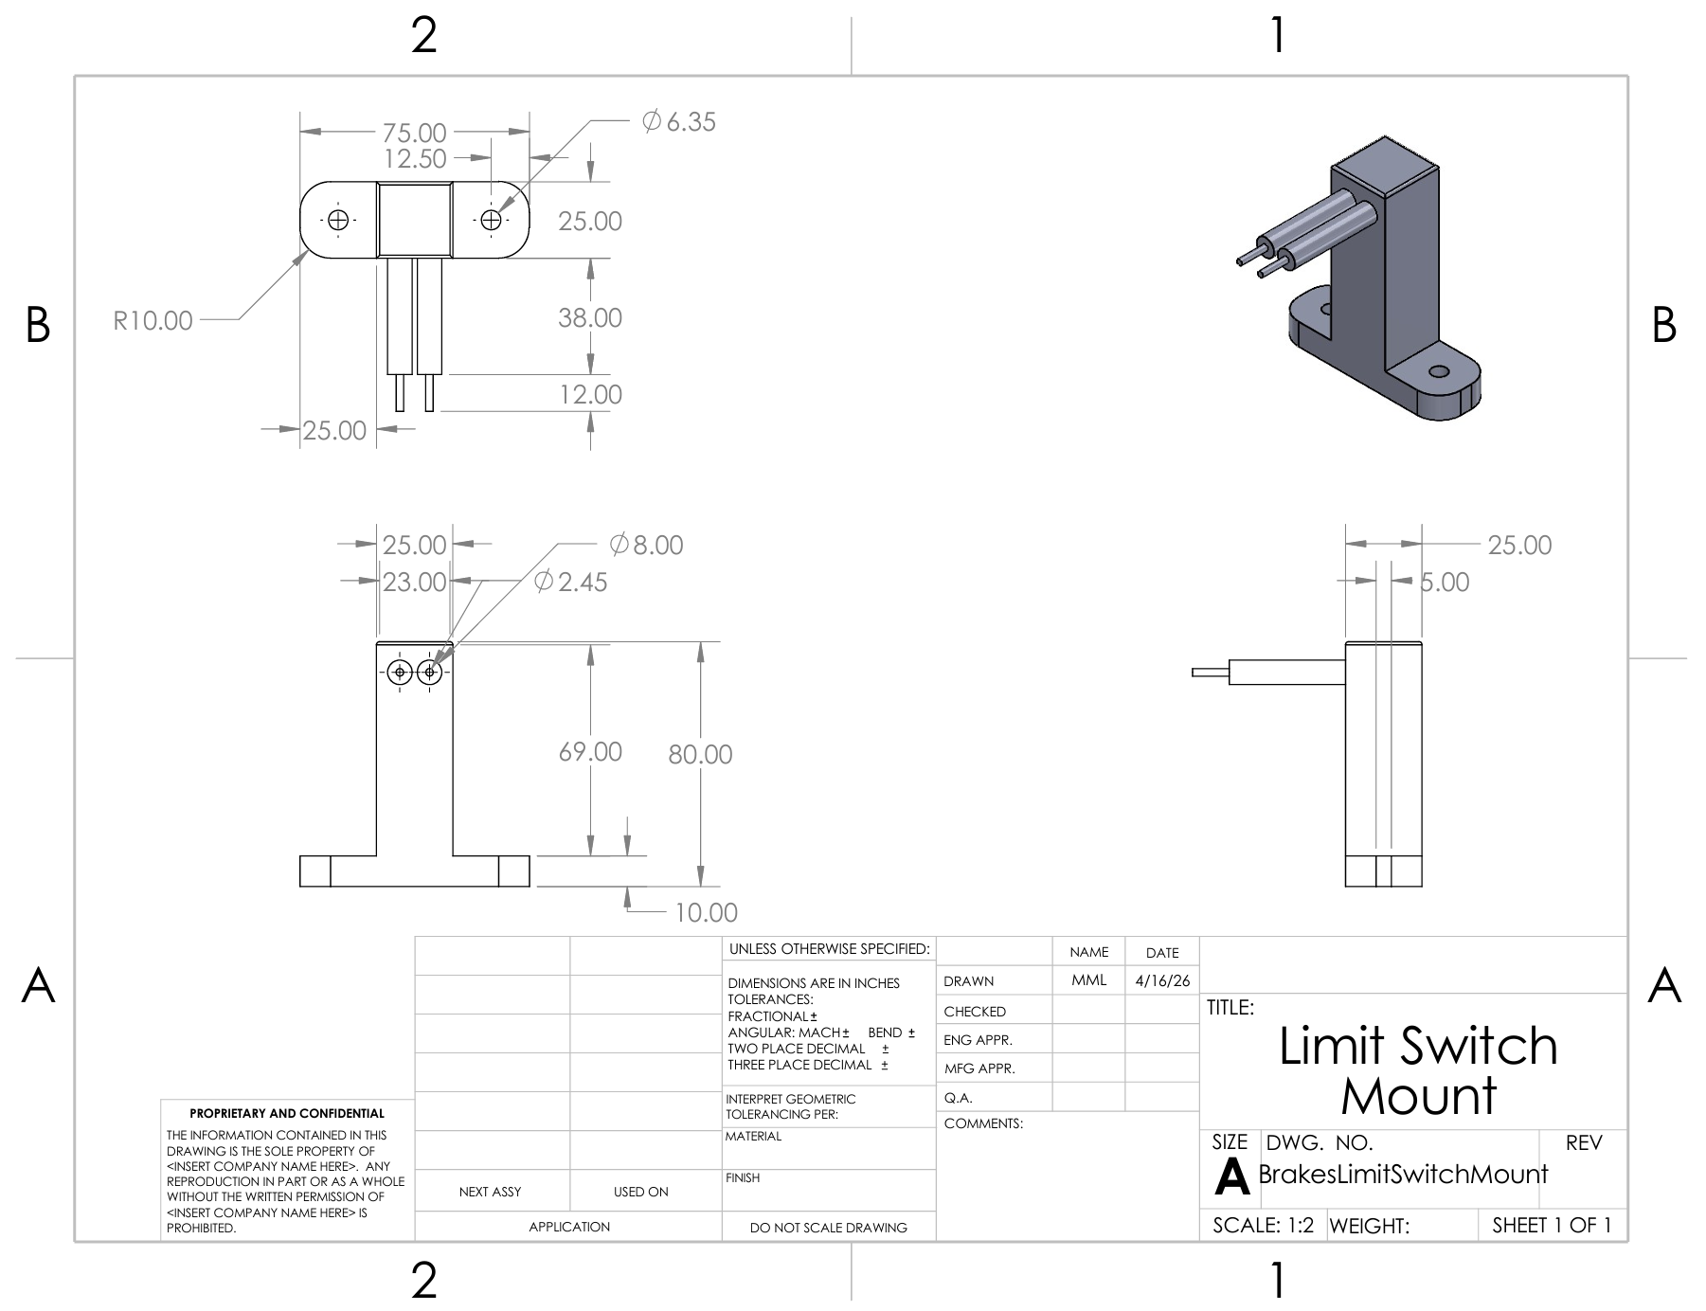
Figure 12: Limit Switch Mount
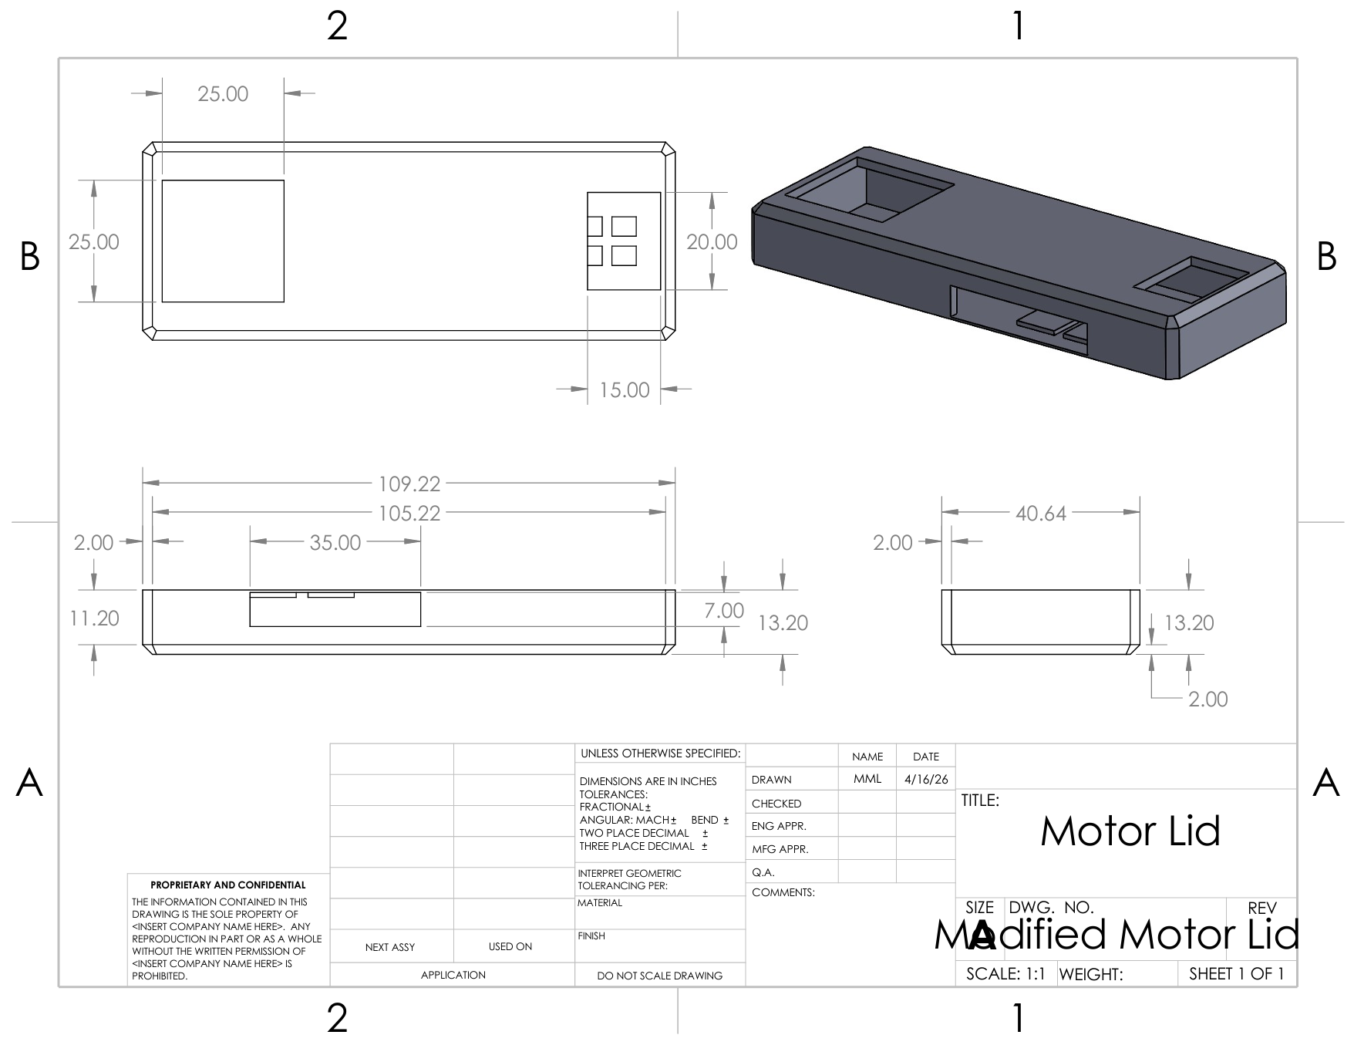
Figure 13: Modified Motor Lid
Steering
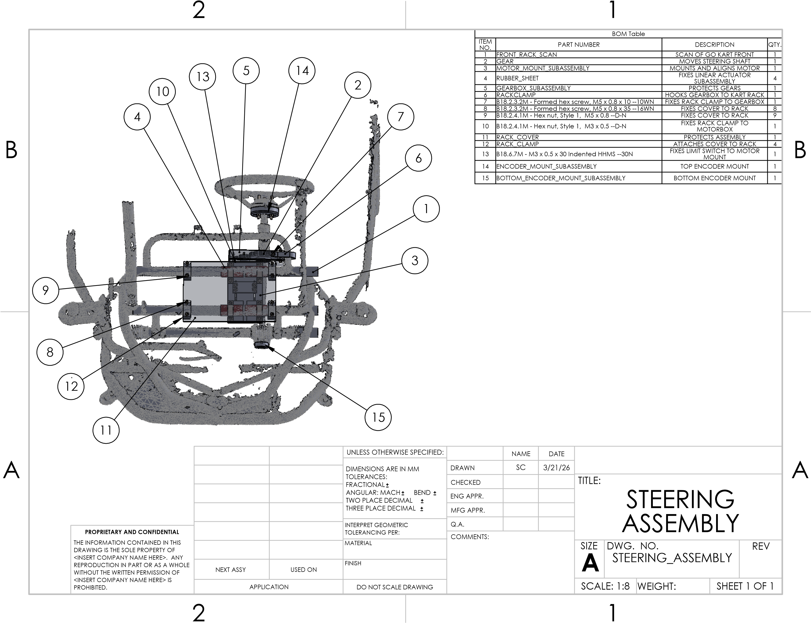
Figure 14: Top Level Drawing of Steering Assembly
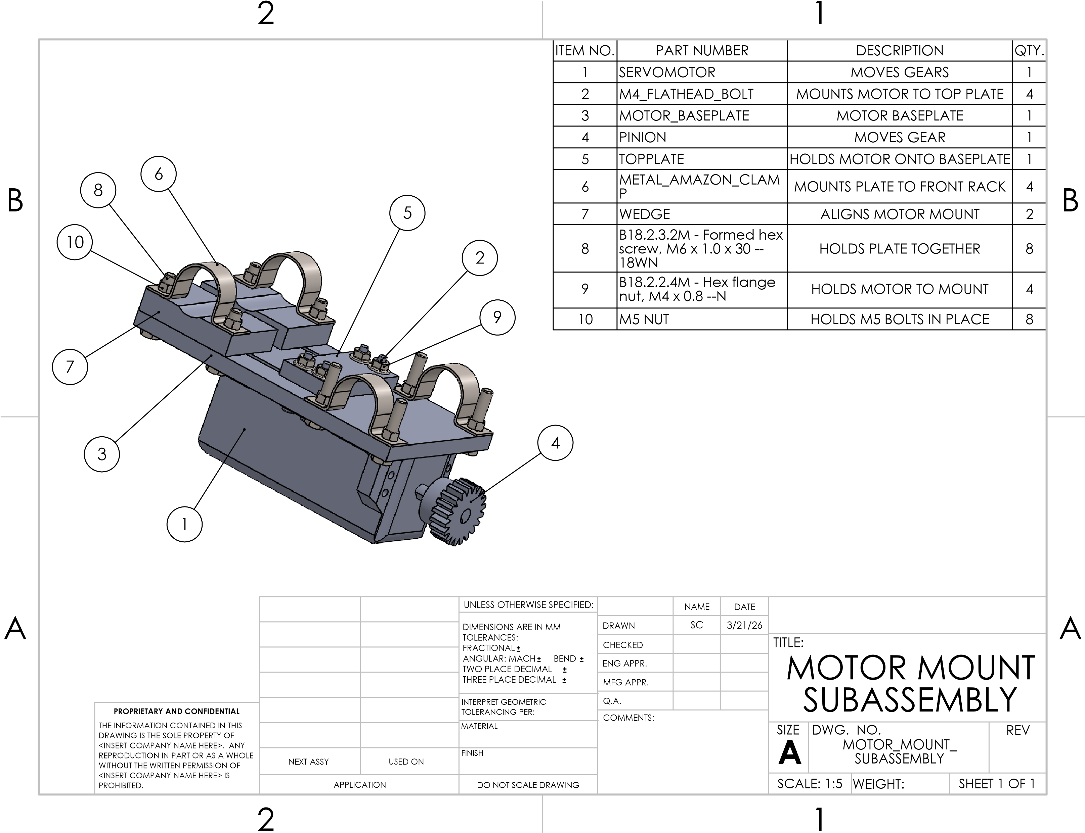
Figure 15: Motor Mount Subassembly
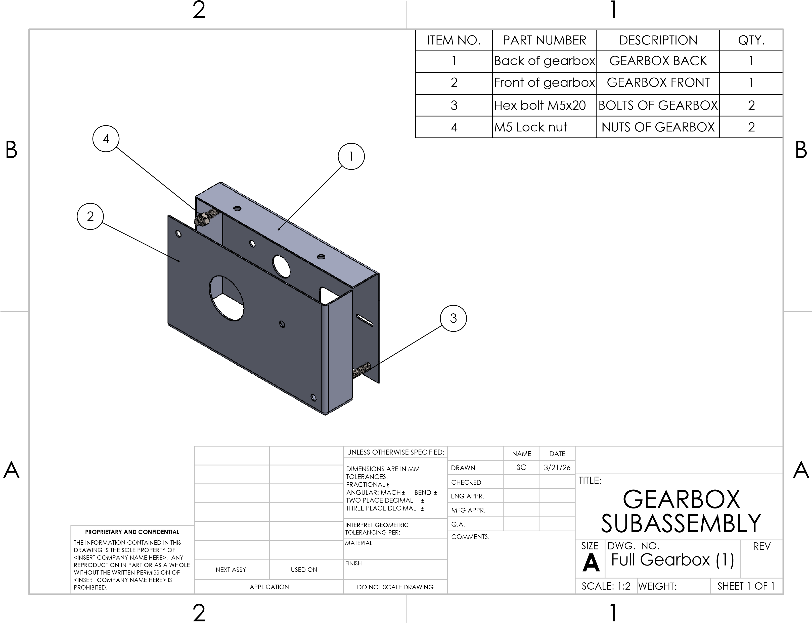
Figure 16: Gearbox Subassembly
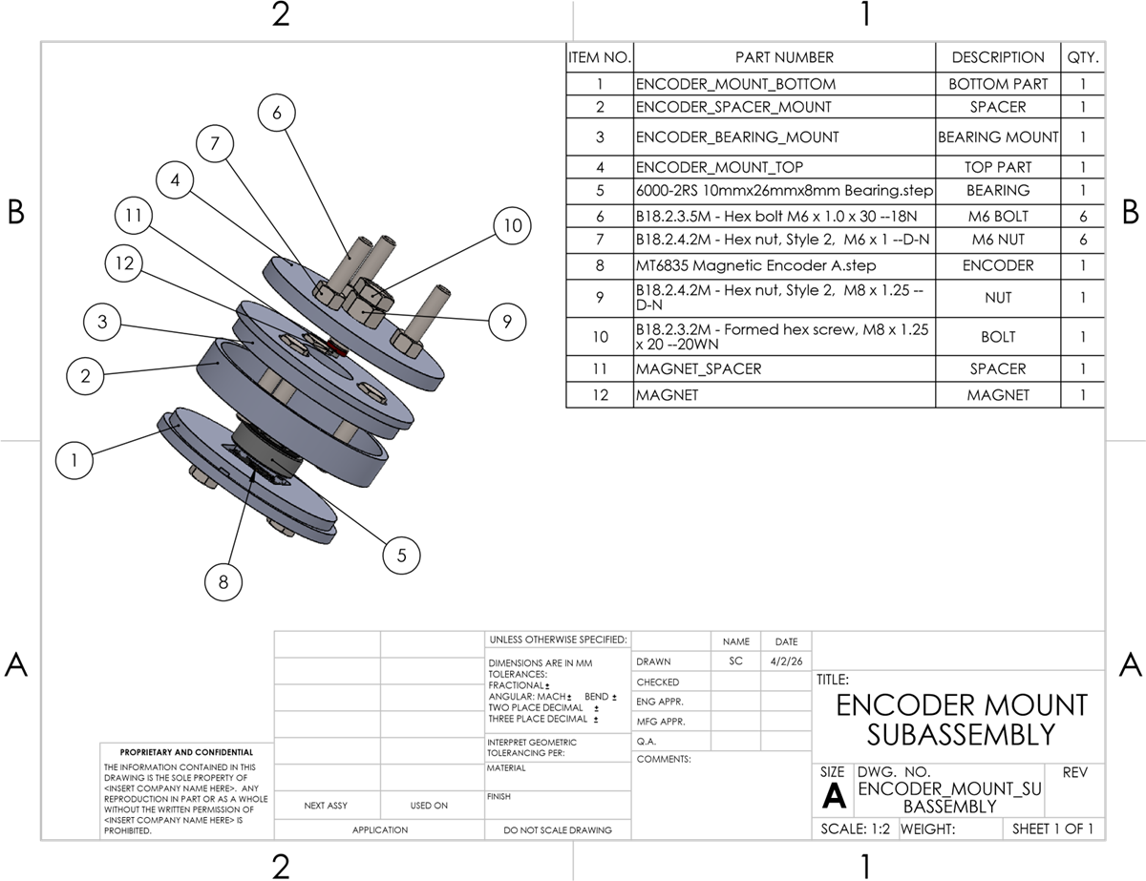
Figure 17: Encoder Mount Subassembly
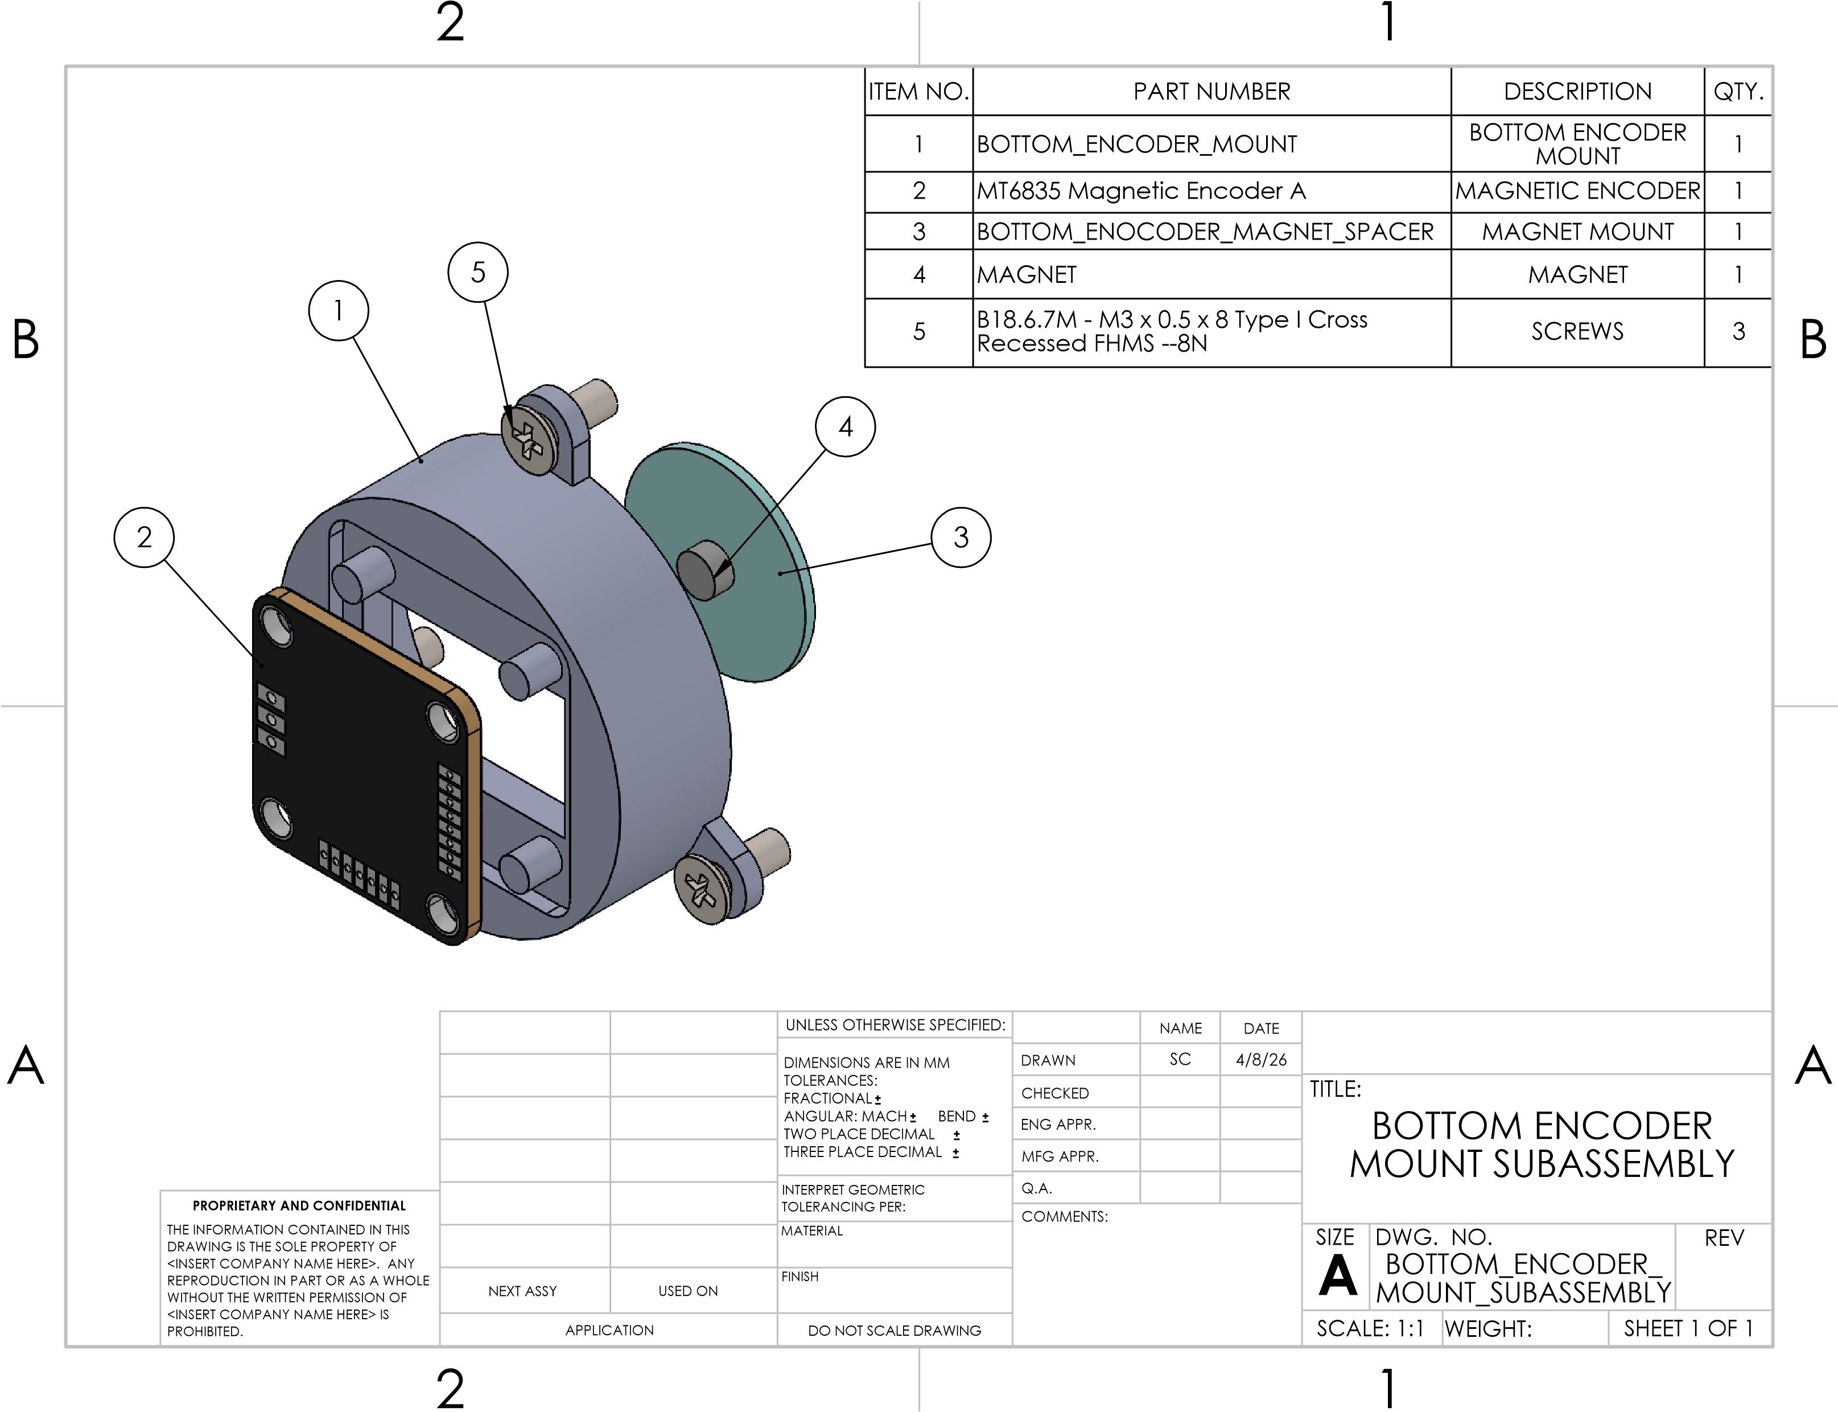
Figure 18: Bottom Encoder Mount Subassembly
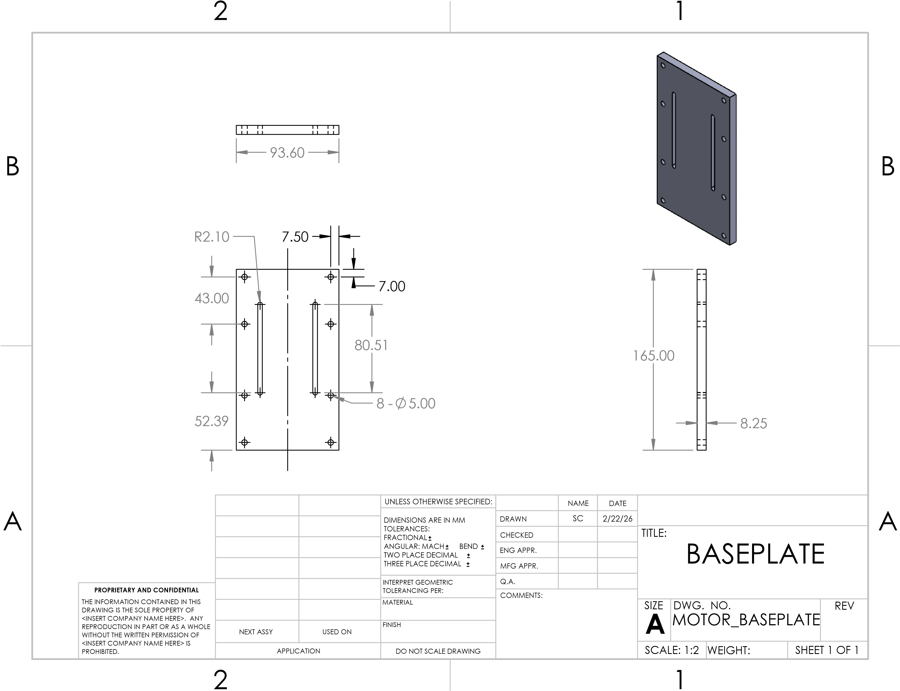
Figure 19: Baseplate
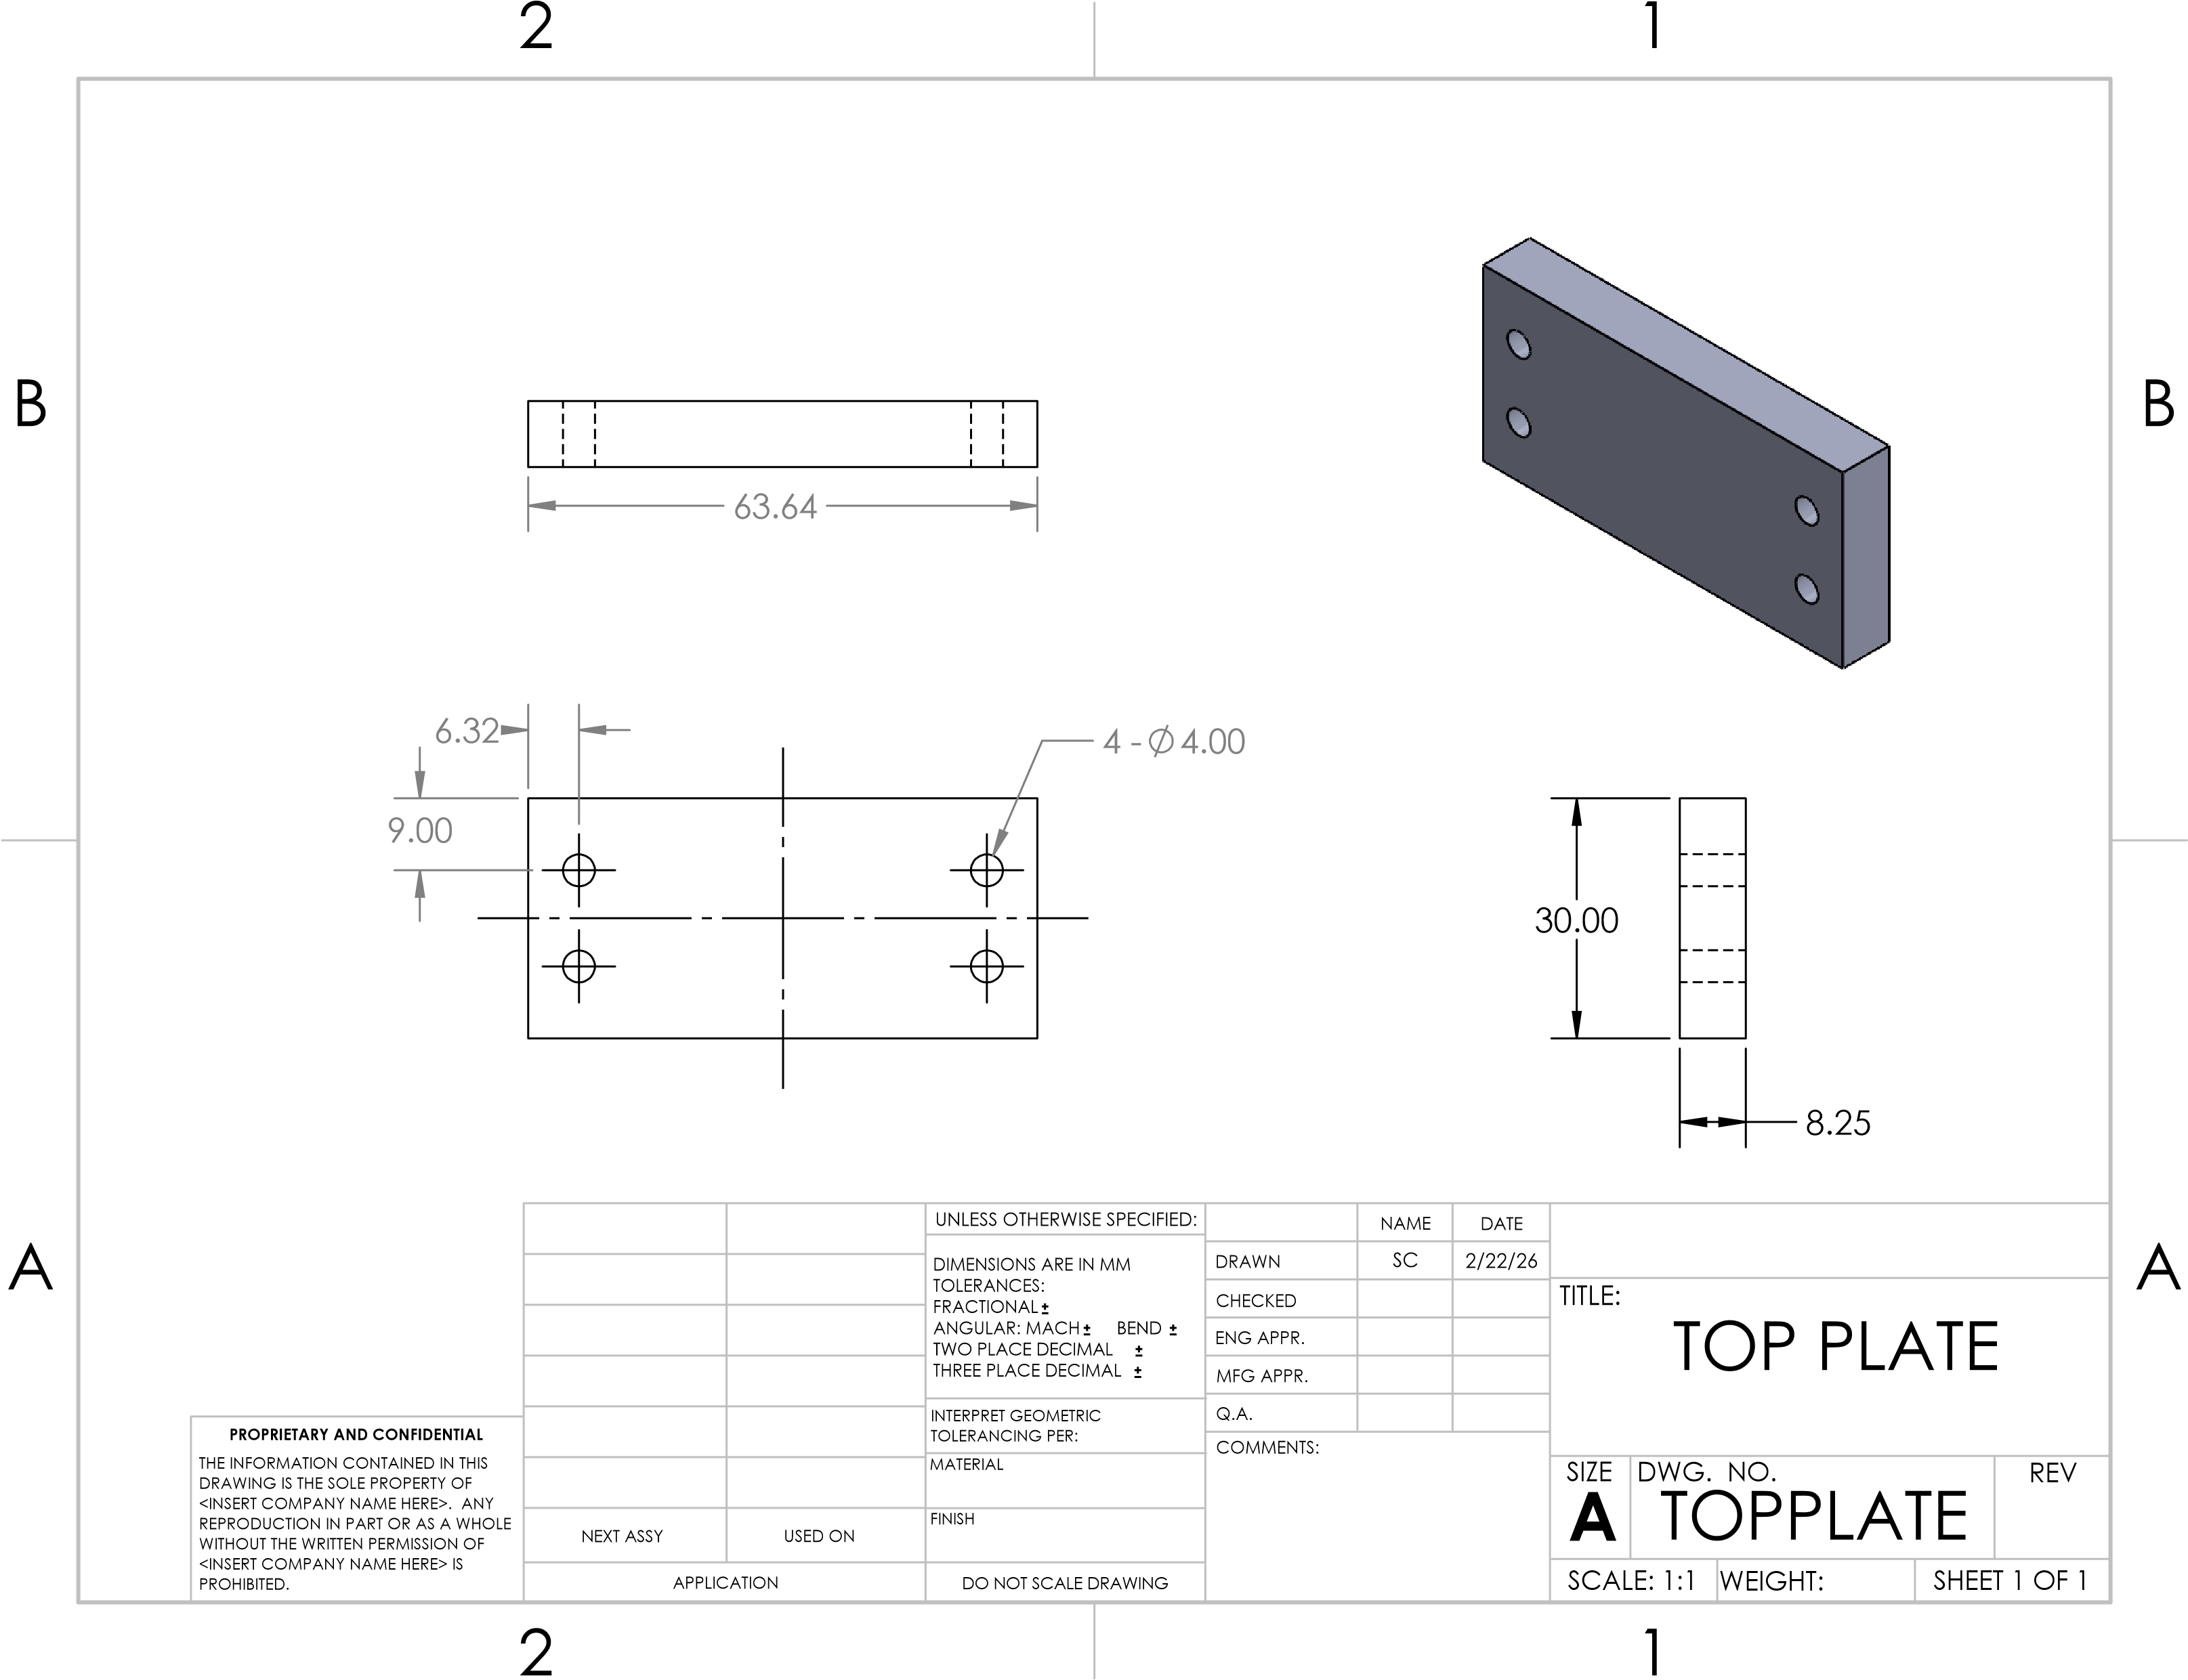
Figure 20: Top Plate
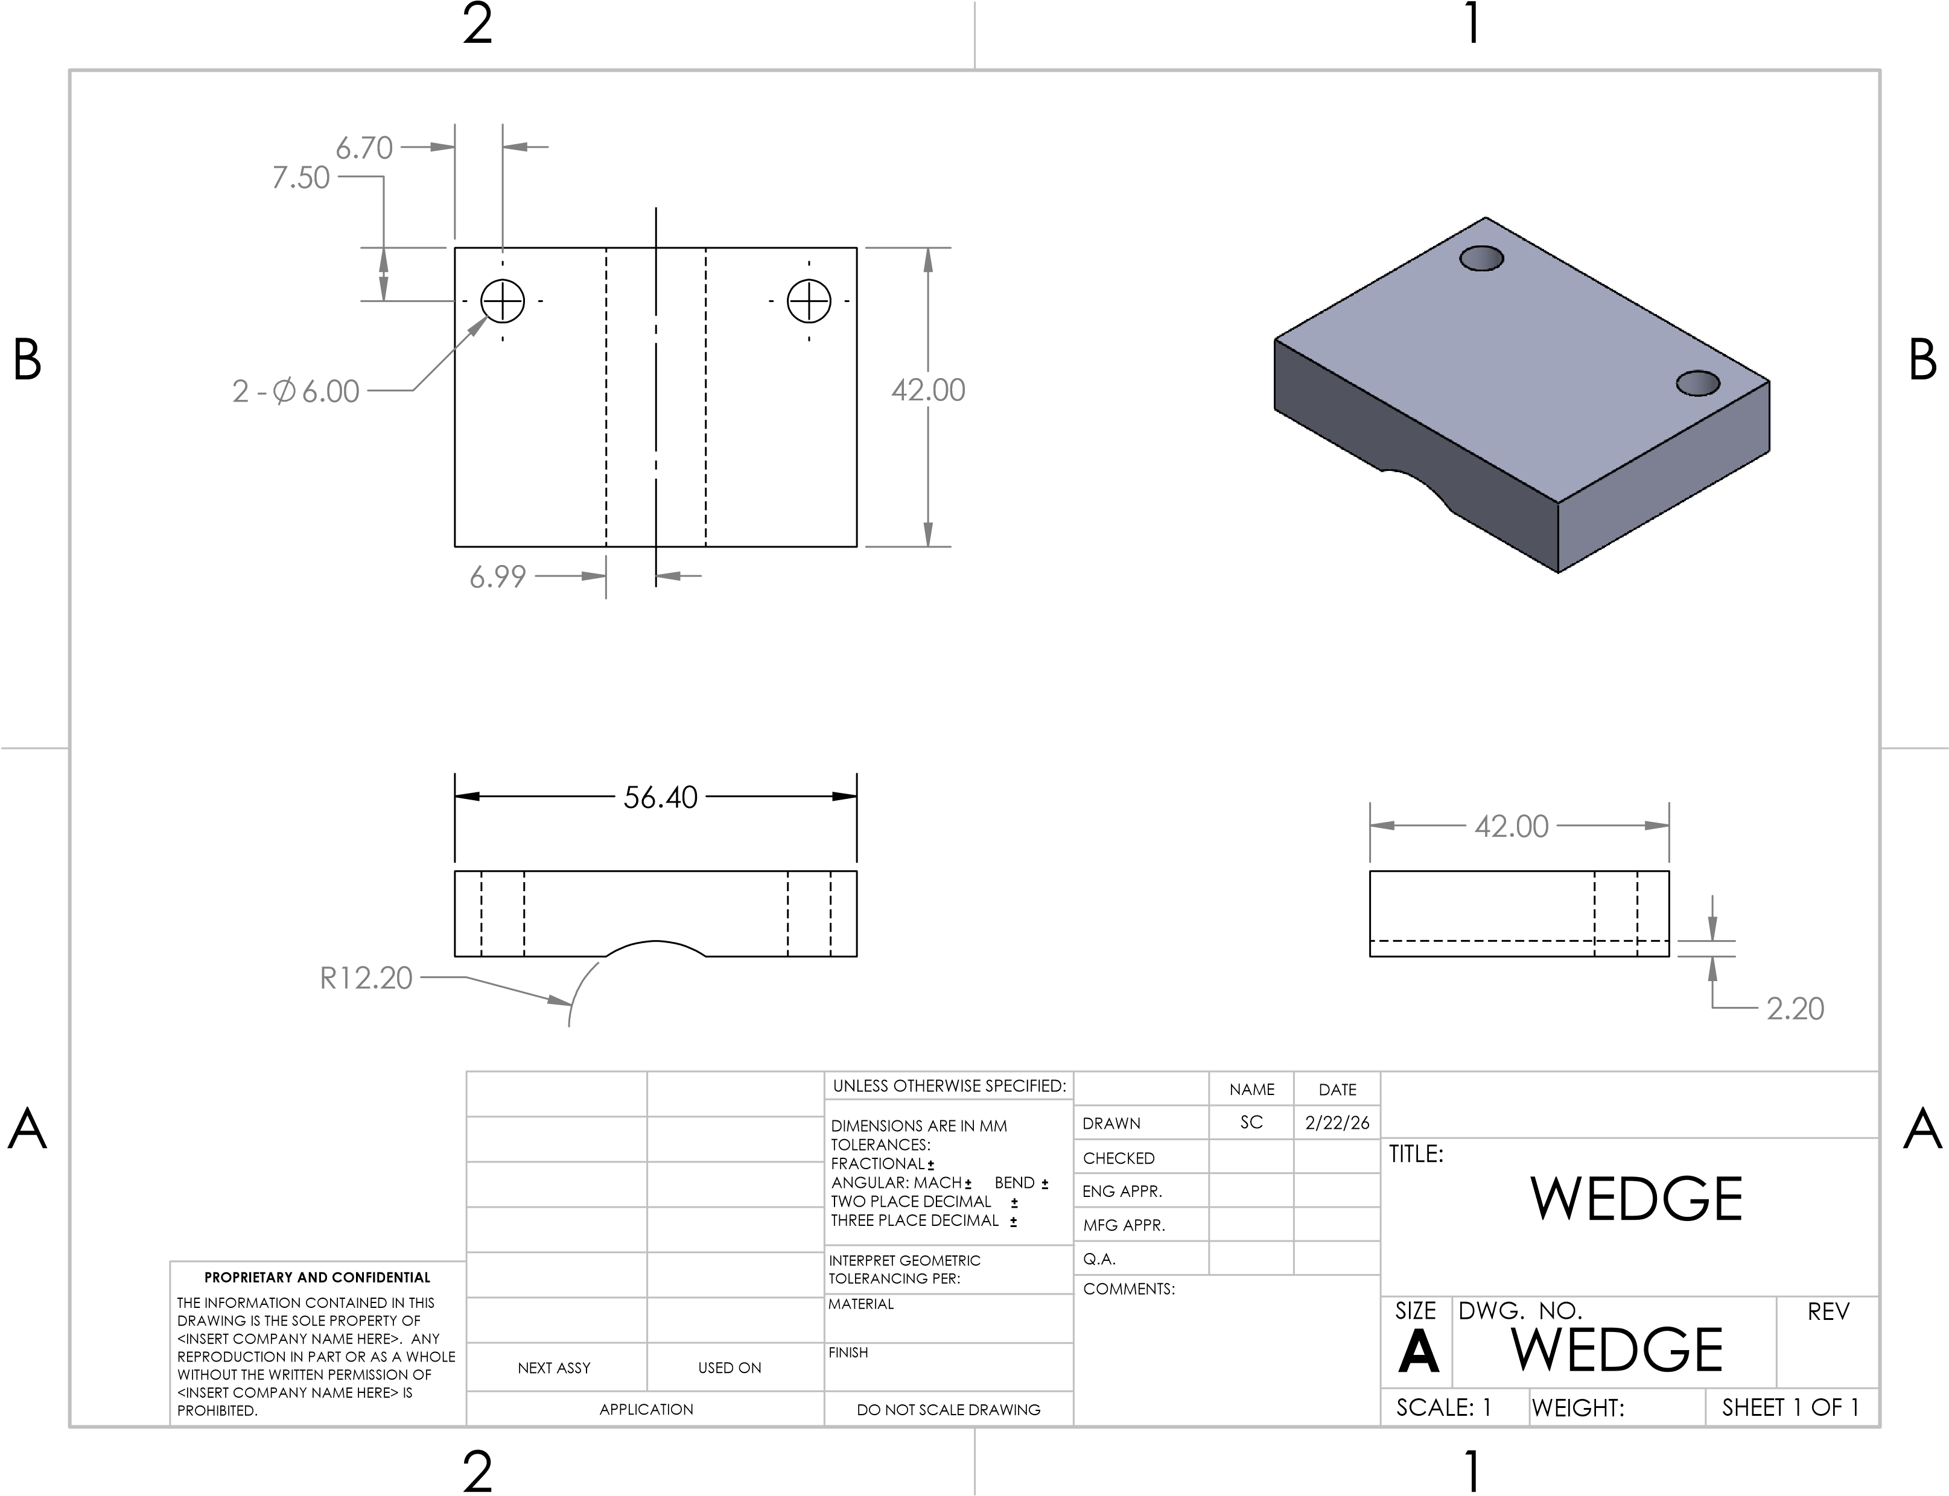
Figure 21: Wedge
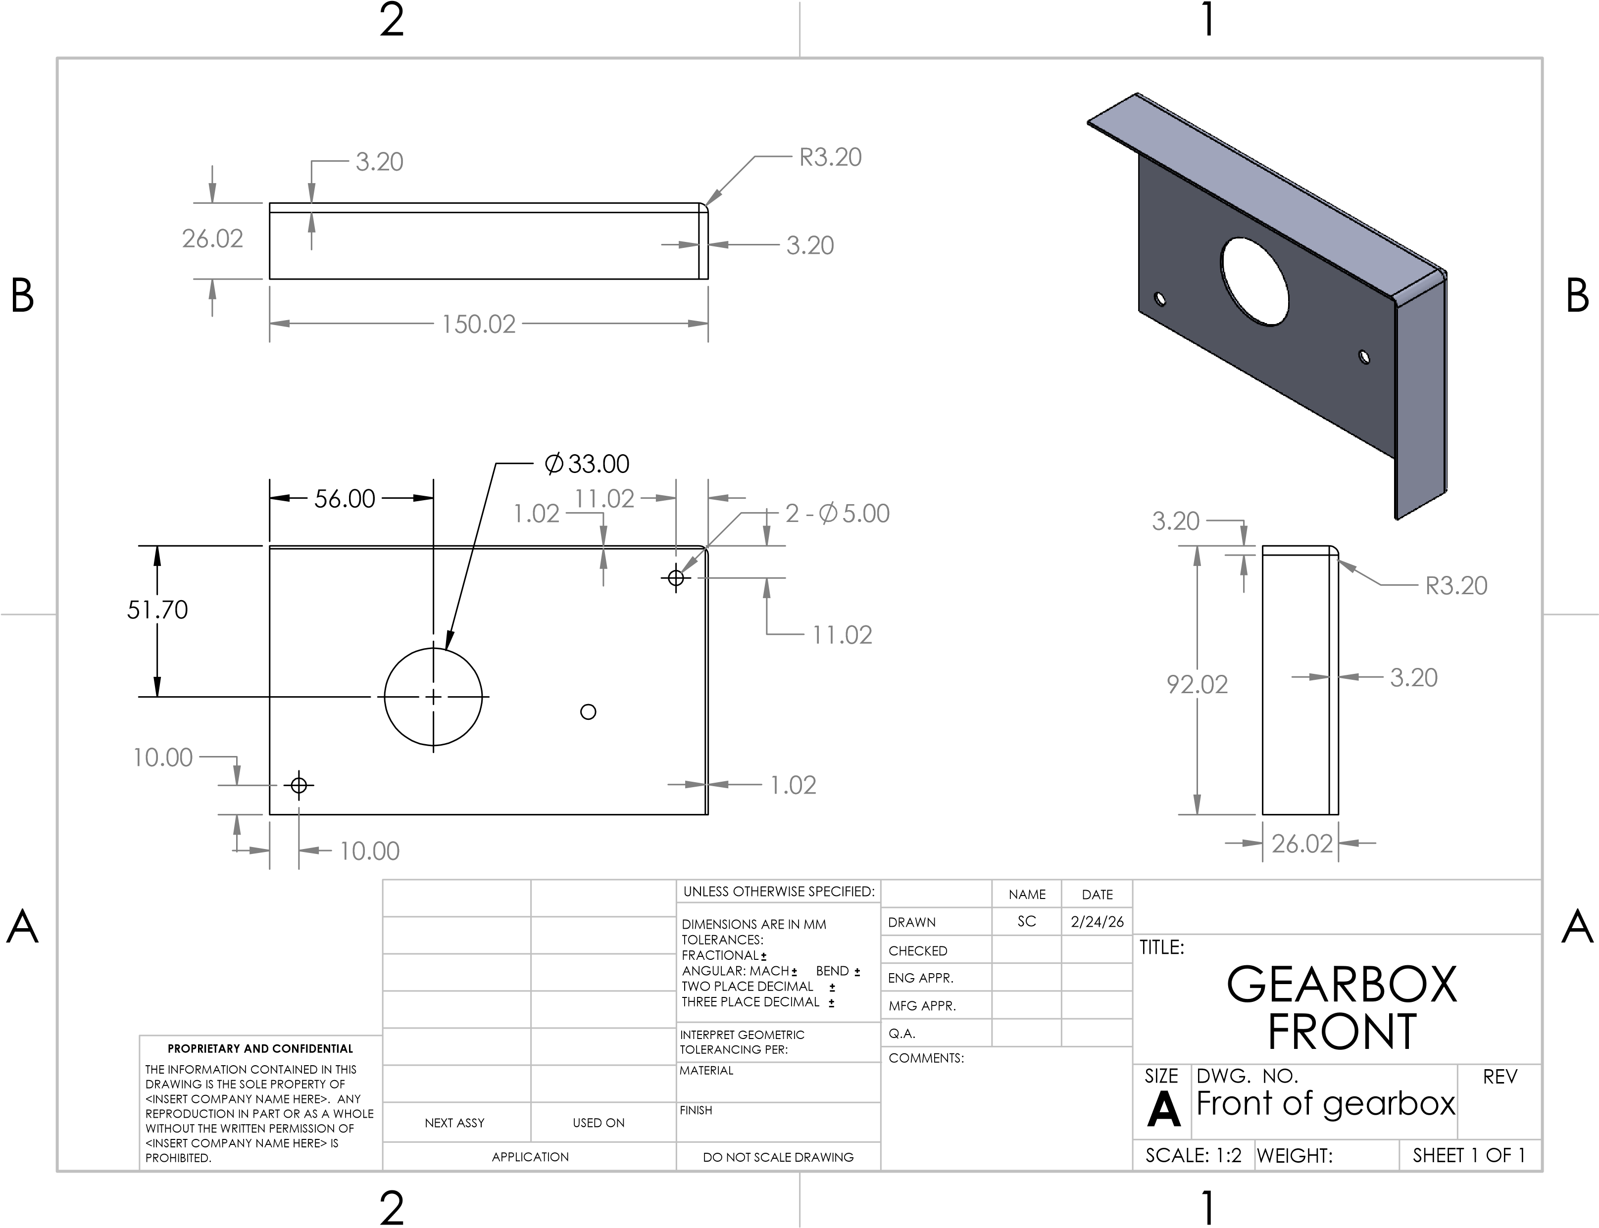
Figure 22: Front of Gearbox
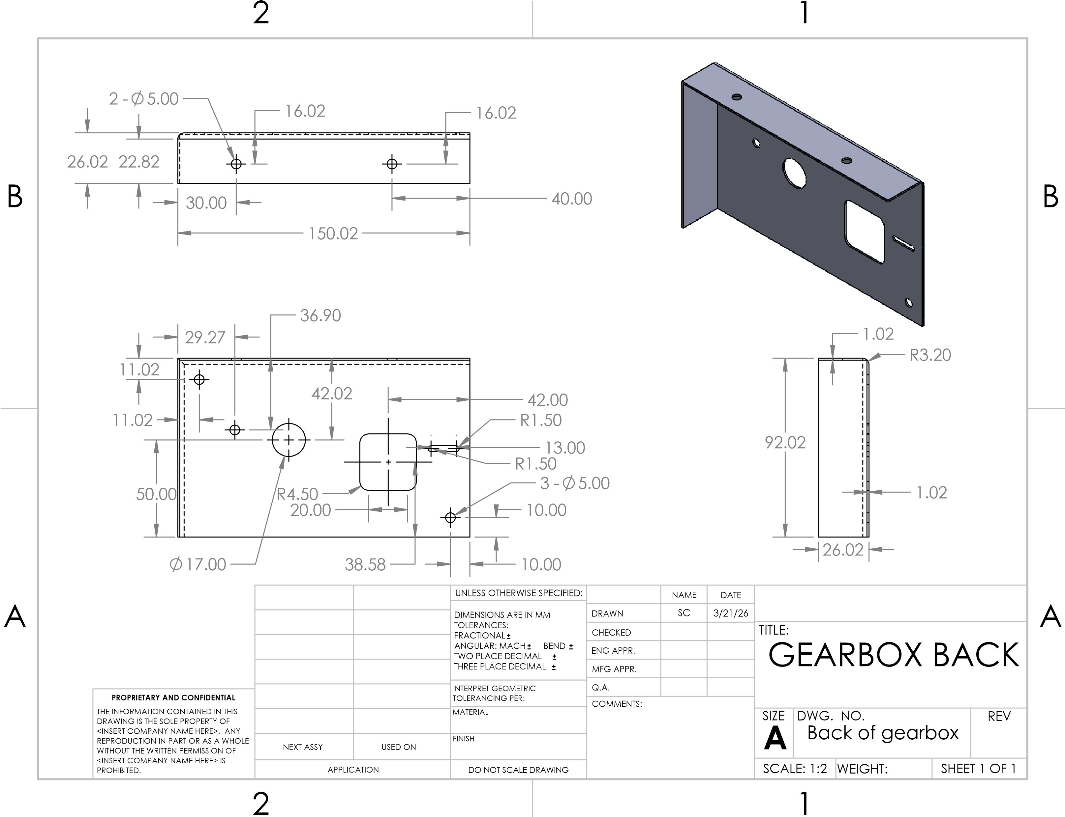
Figure 23: Back of Gearbox
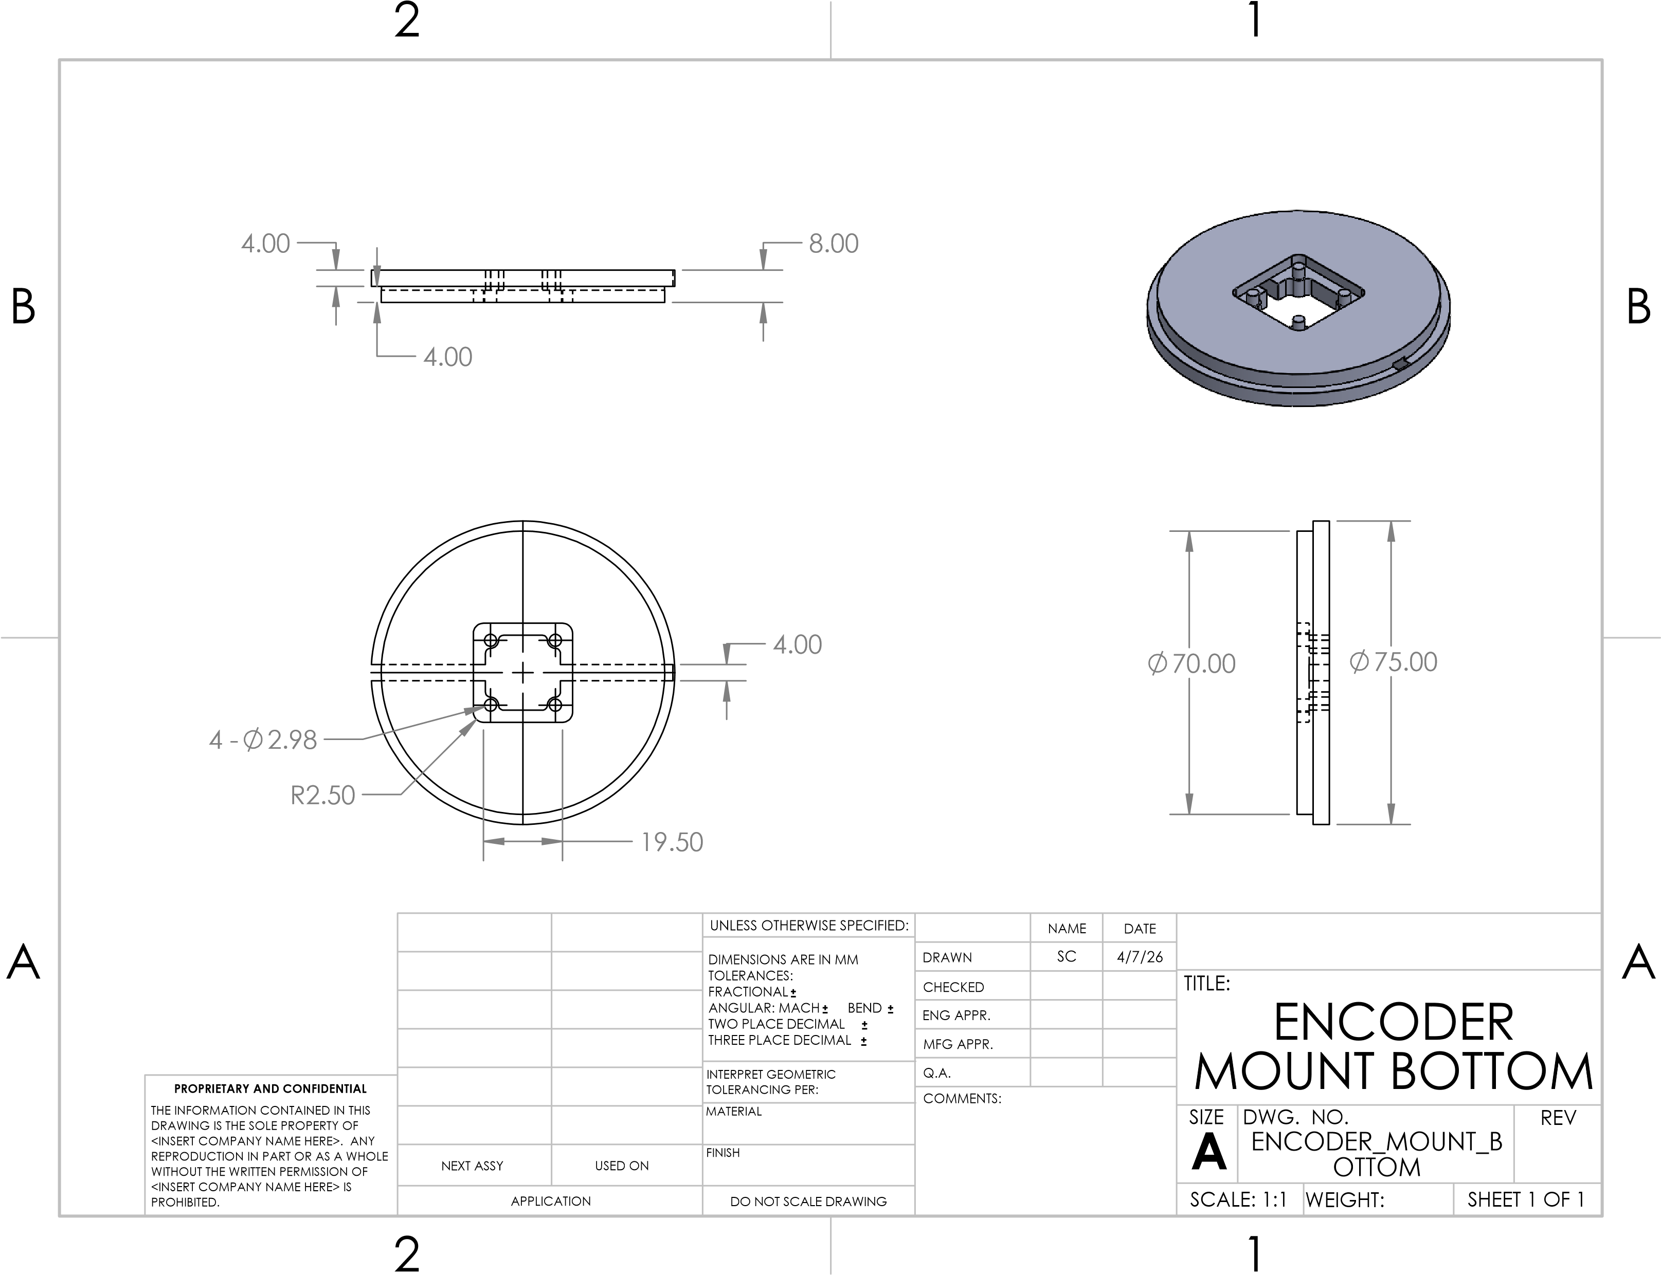
Figure 24: Encoder Mount Bottom
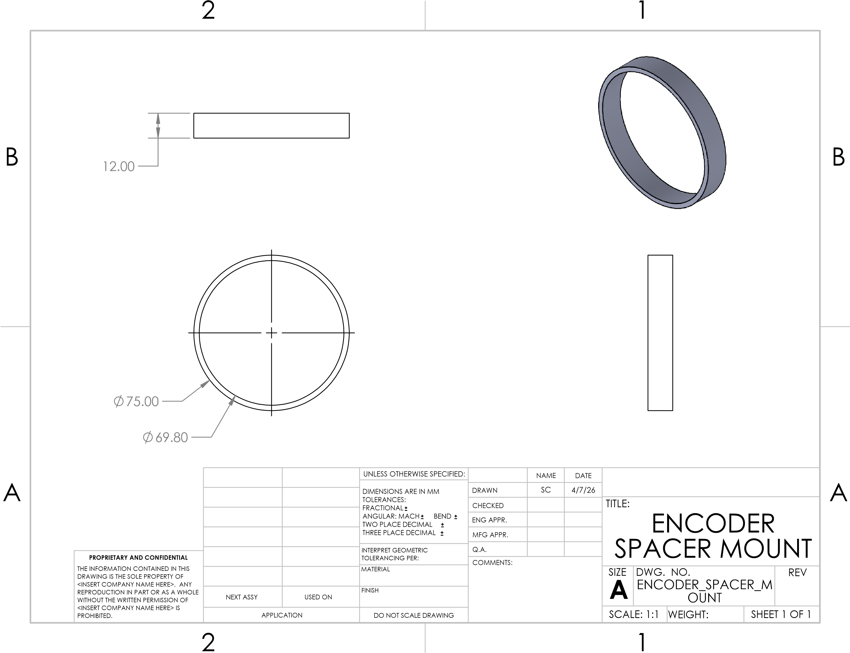
Figure 25: Encoder Spacer Mount
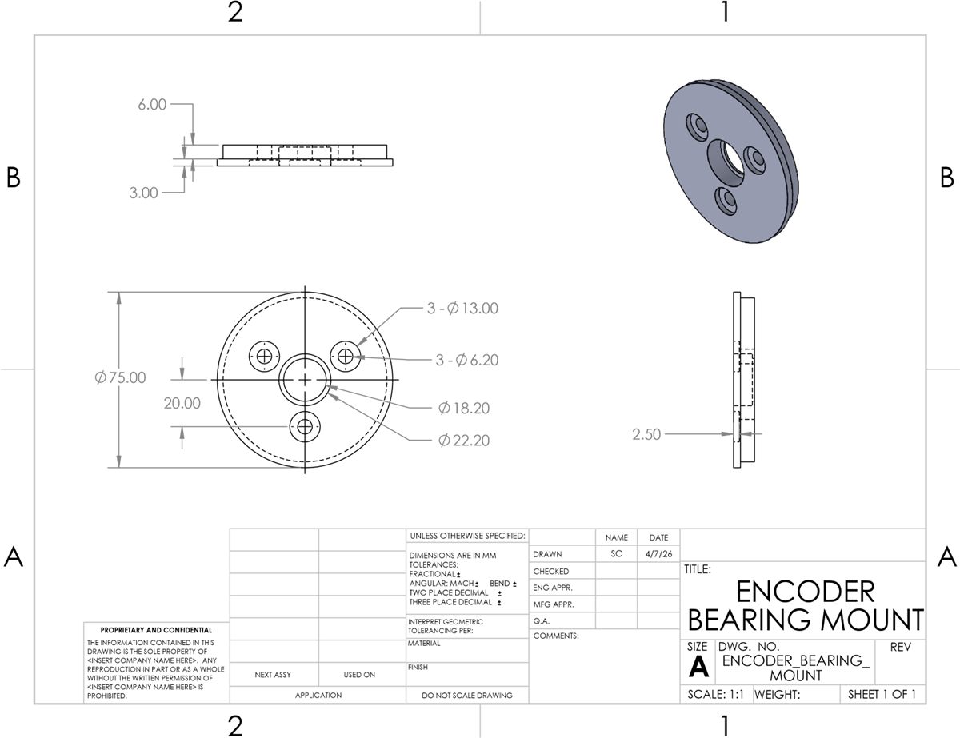
Figure 26: Encoder Bearing Mount
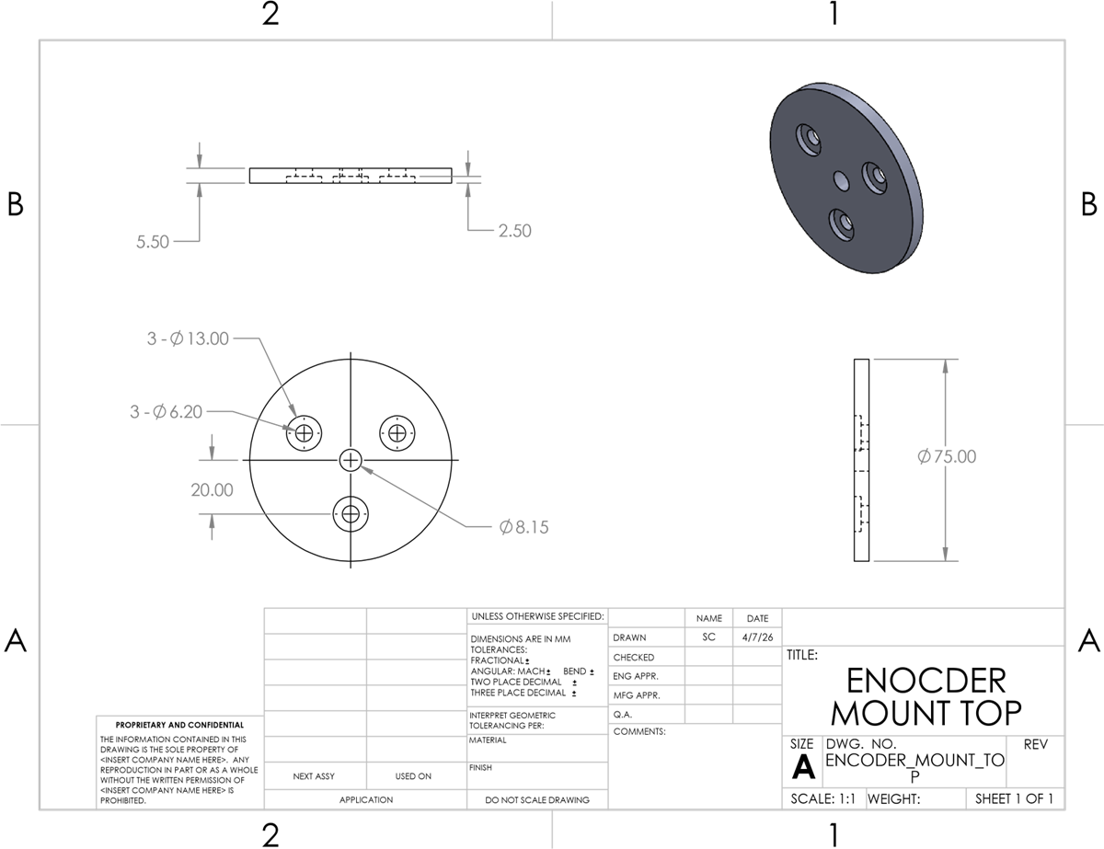
Figure 27: Encoder Mount Top
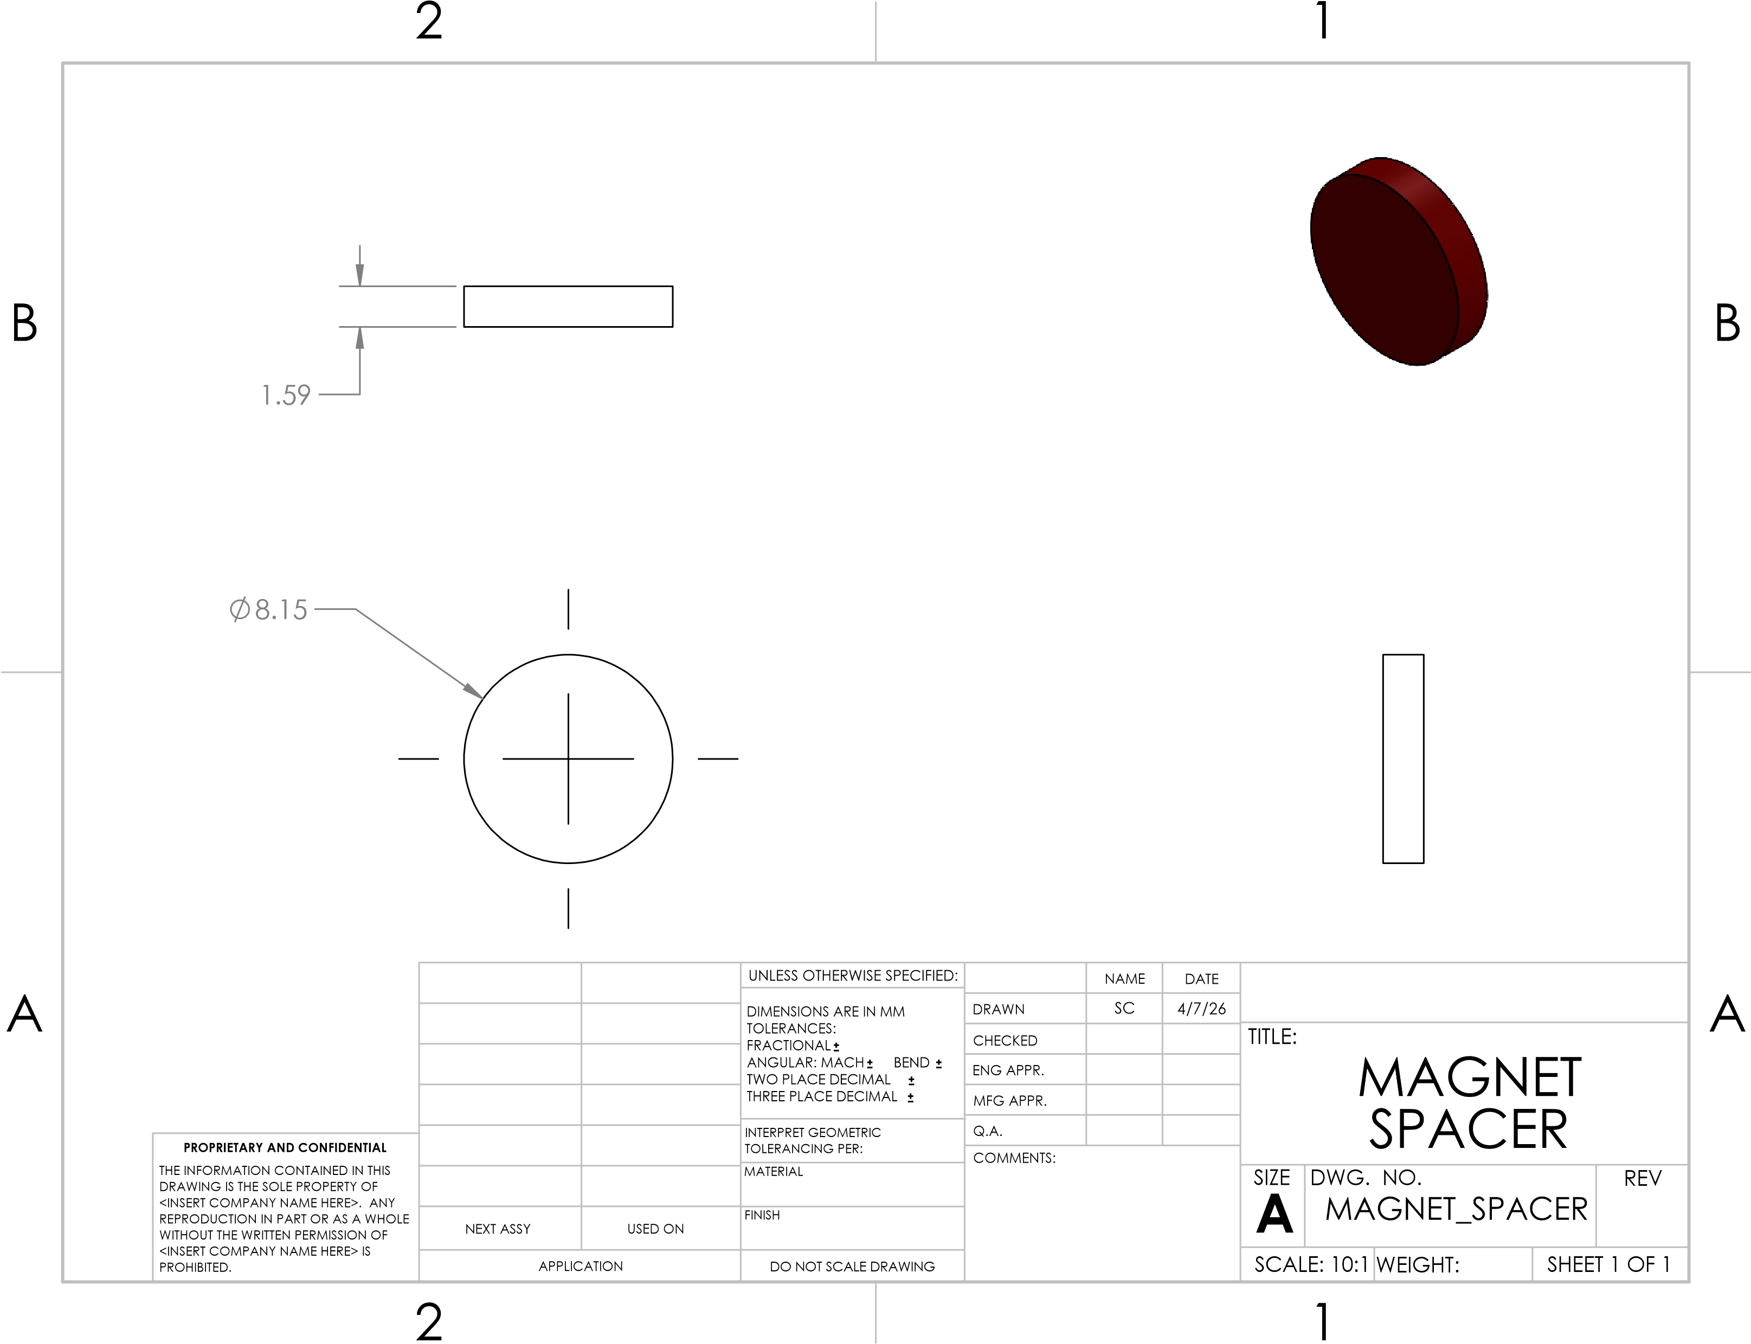
Figure 28: Magnet Spacer
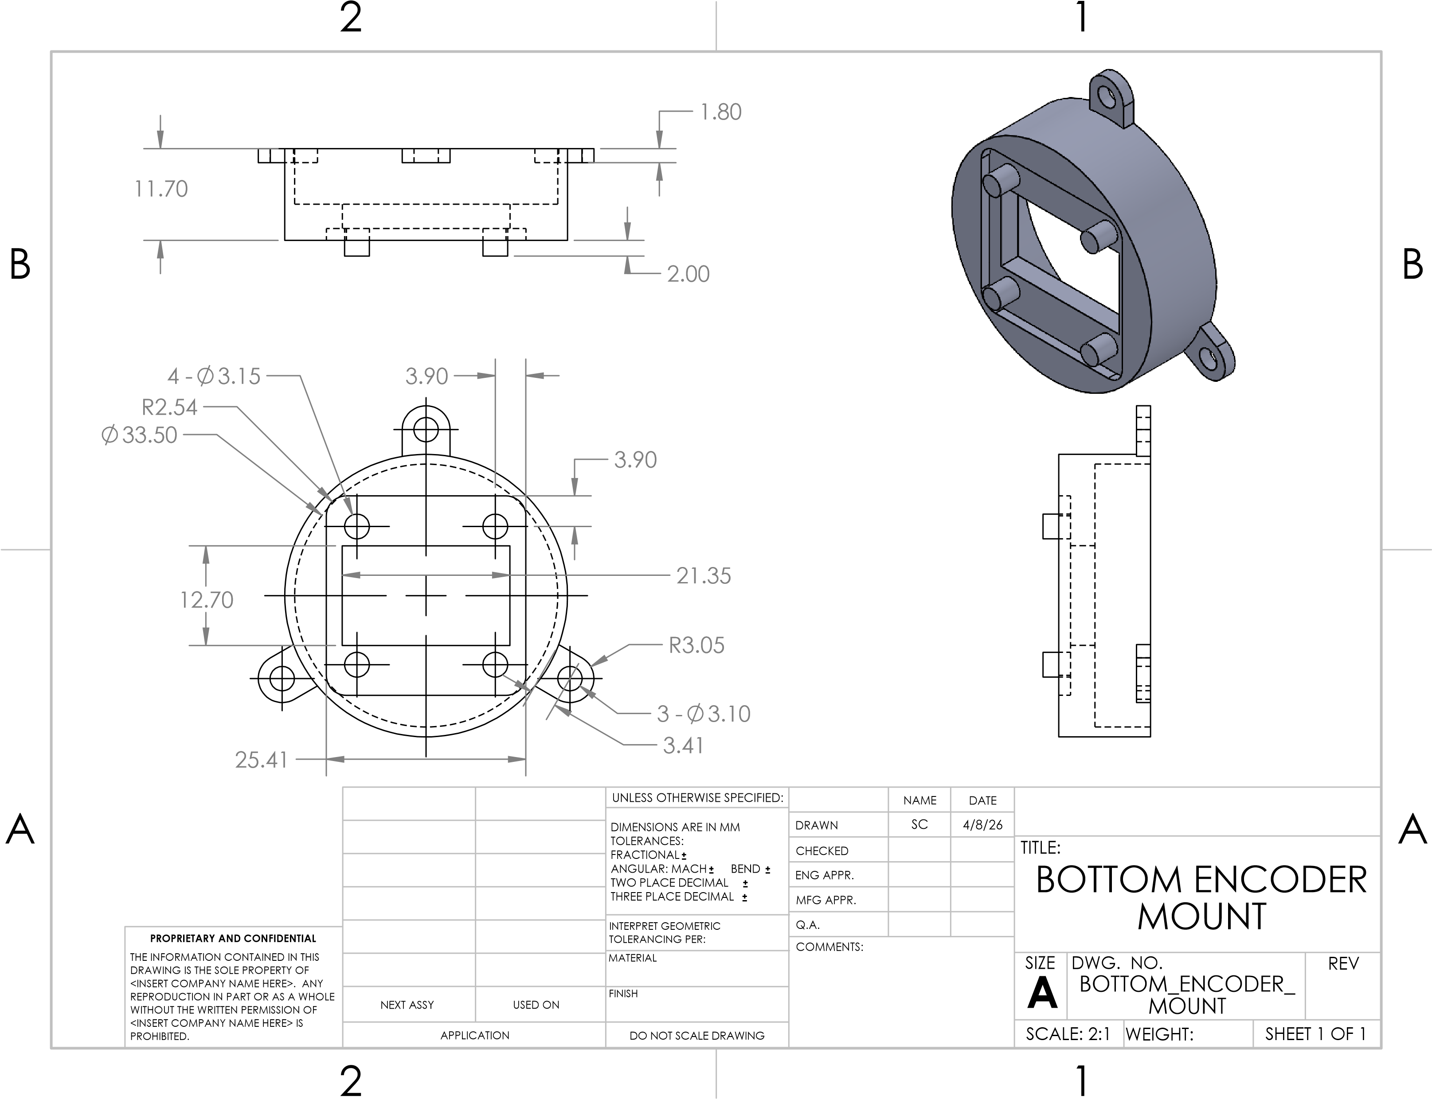
Figure 29: Bottom Encoder Mount
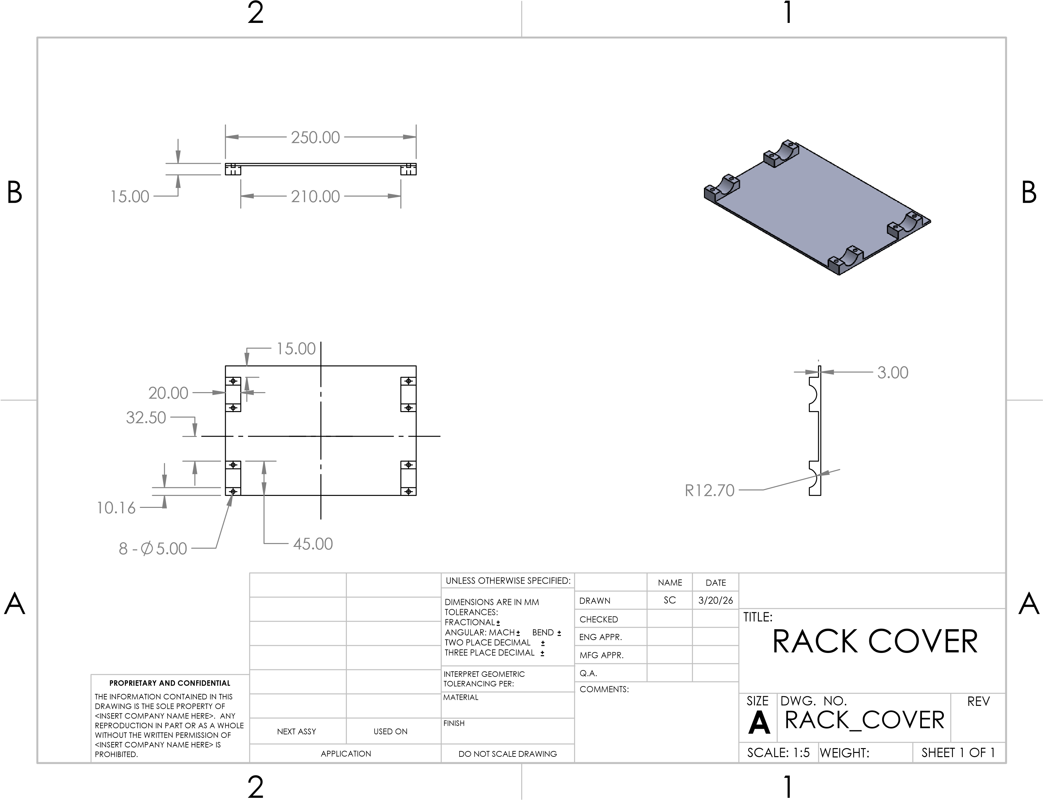
Figure 30: Rack Cover
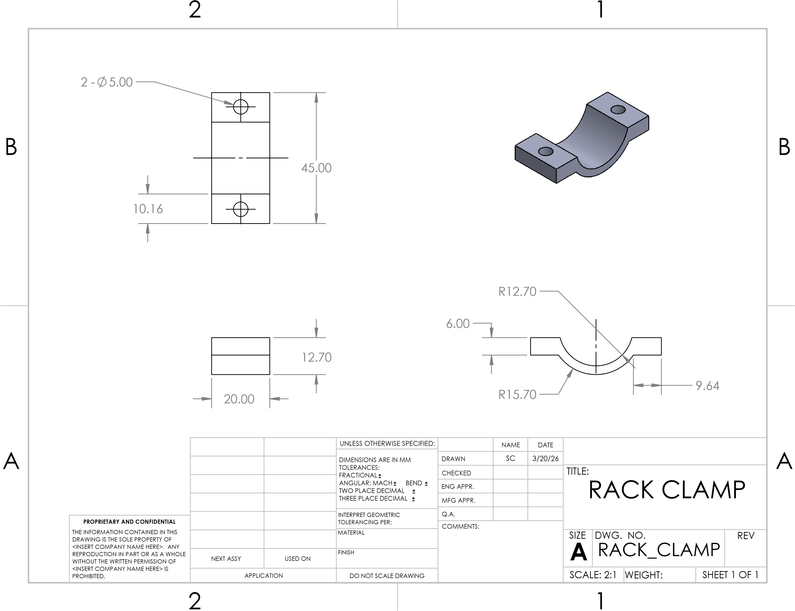
Figure 31: Rack Clamp
Throttle
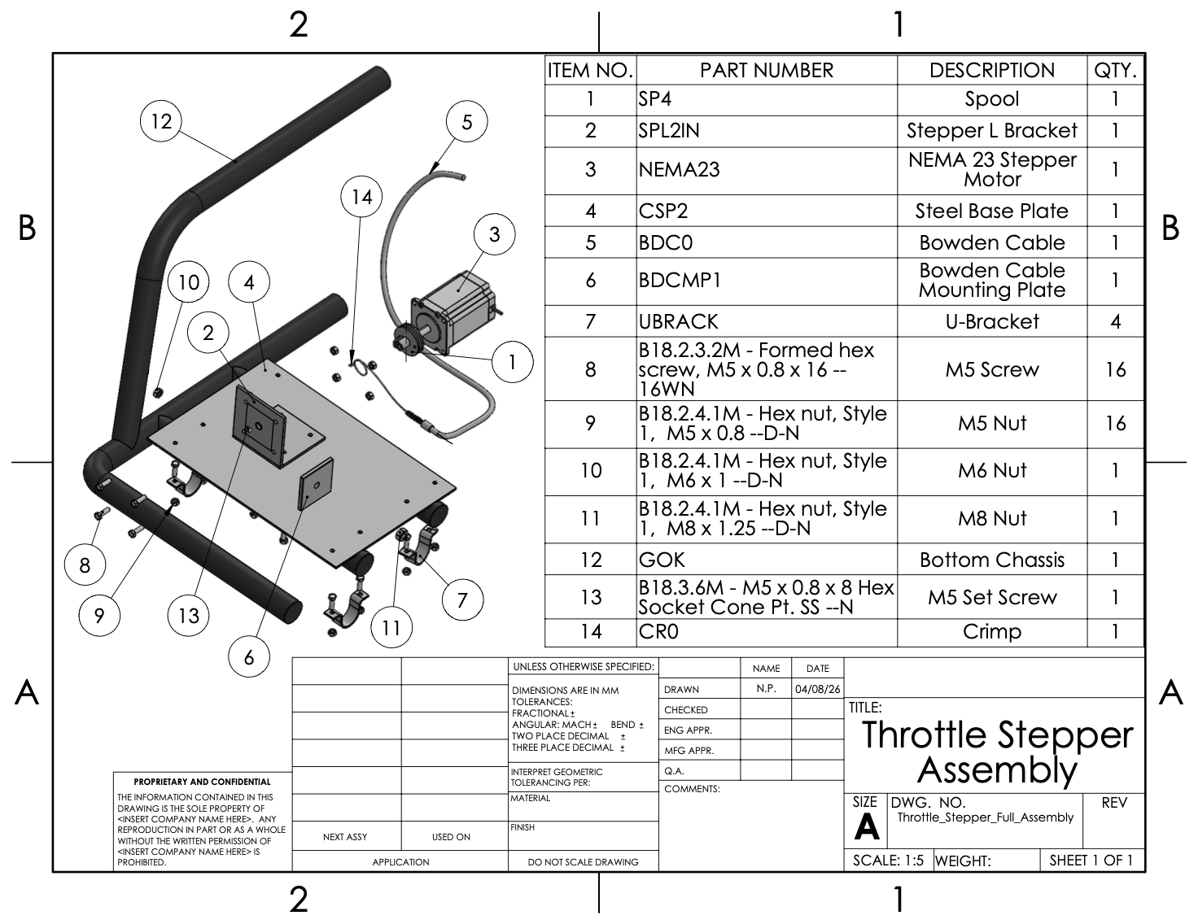
Figure 32: Final Stepper Motor Assembly
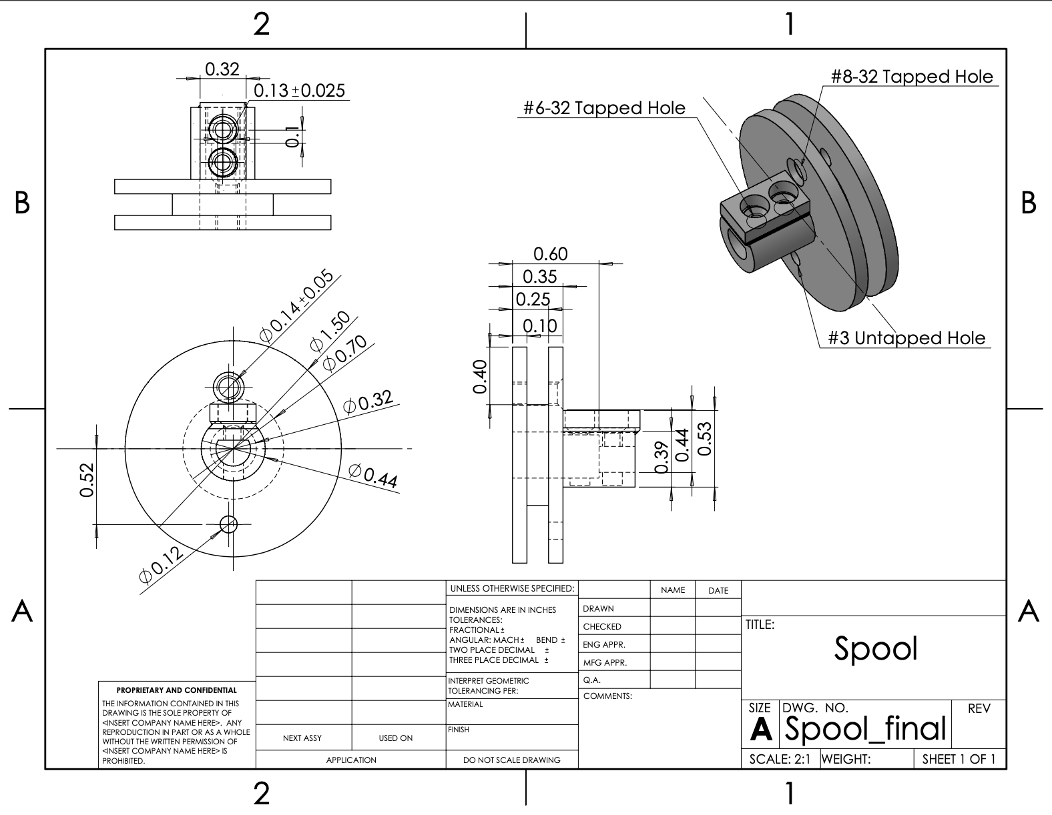
Figure 33: Updated Spool
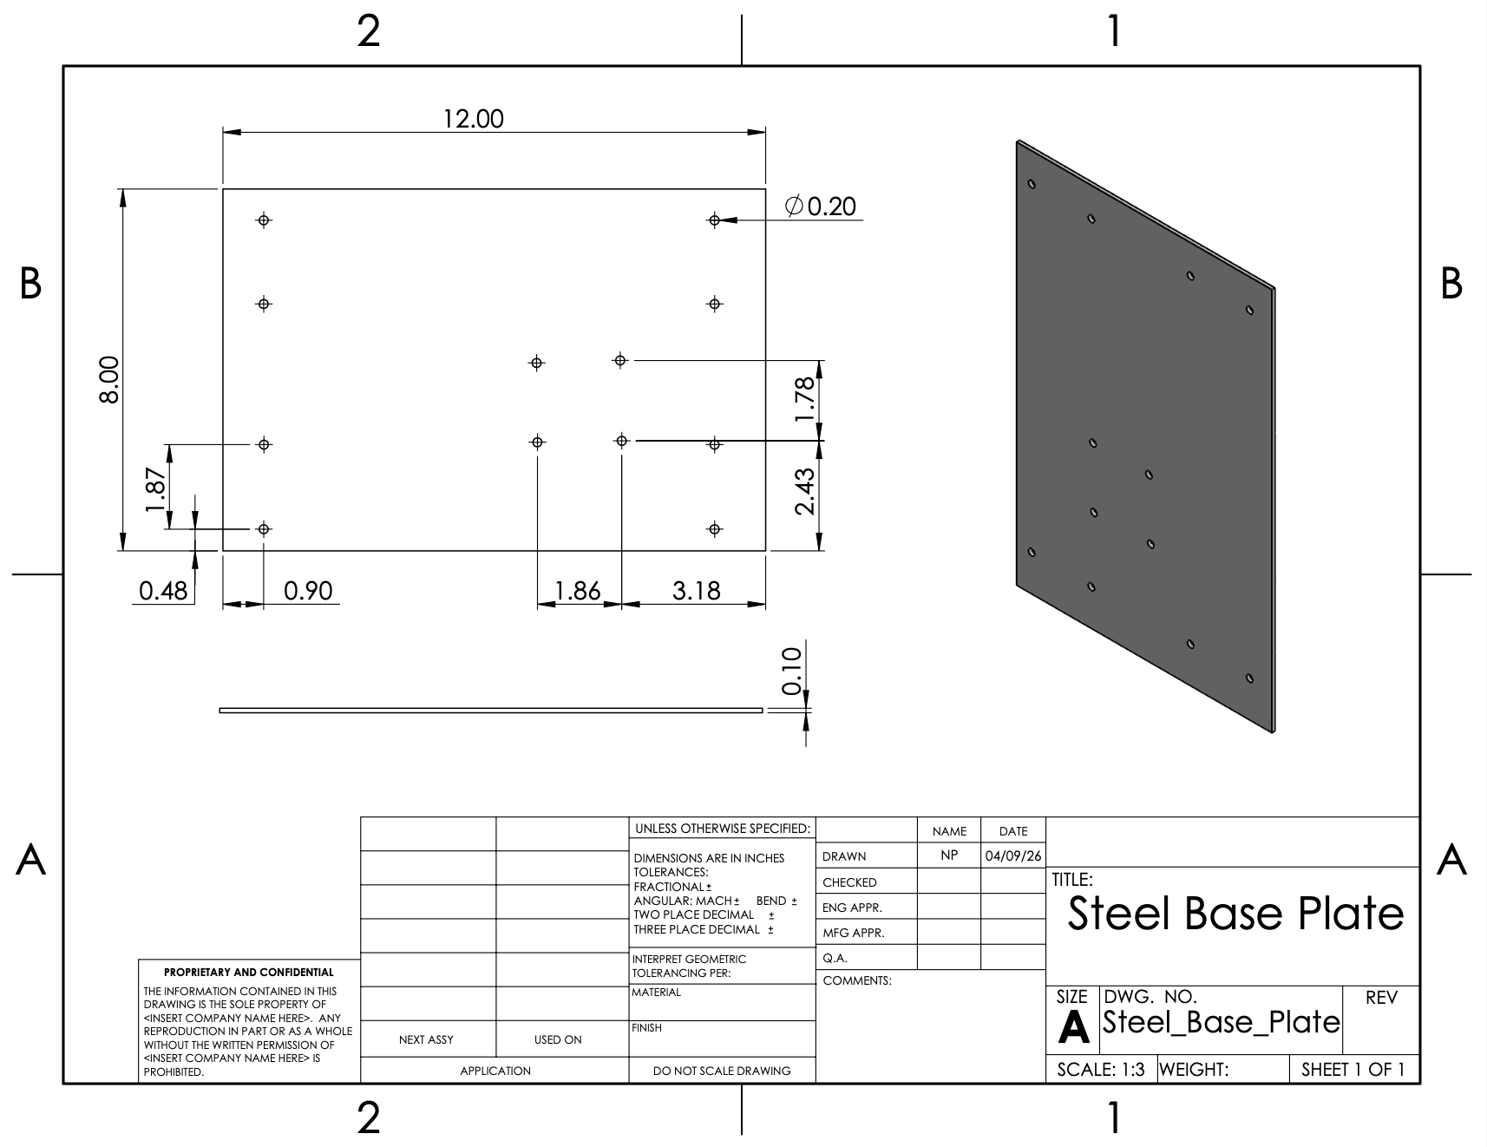
Figure 34: Steel Base Plate
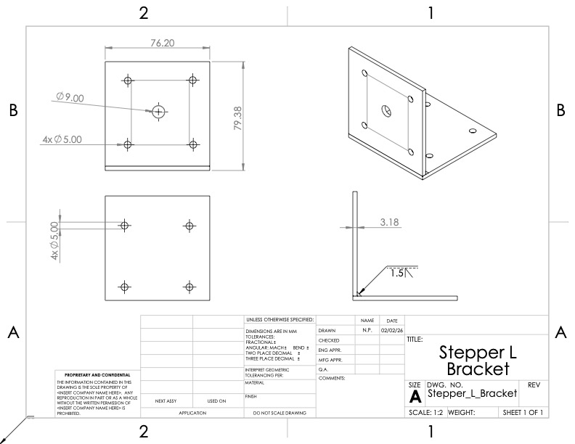
Figure 35: Stepper Motor L- Bracket
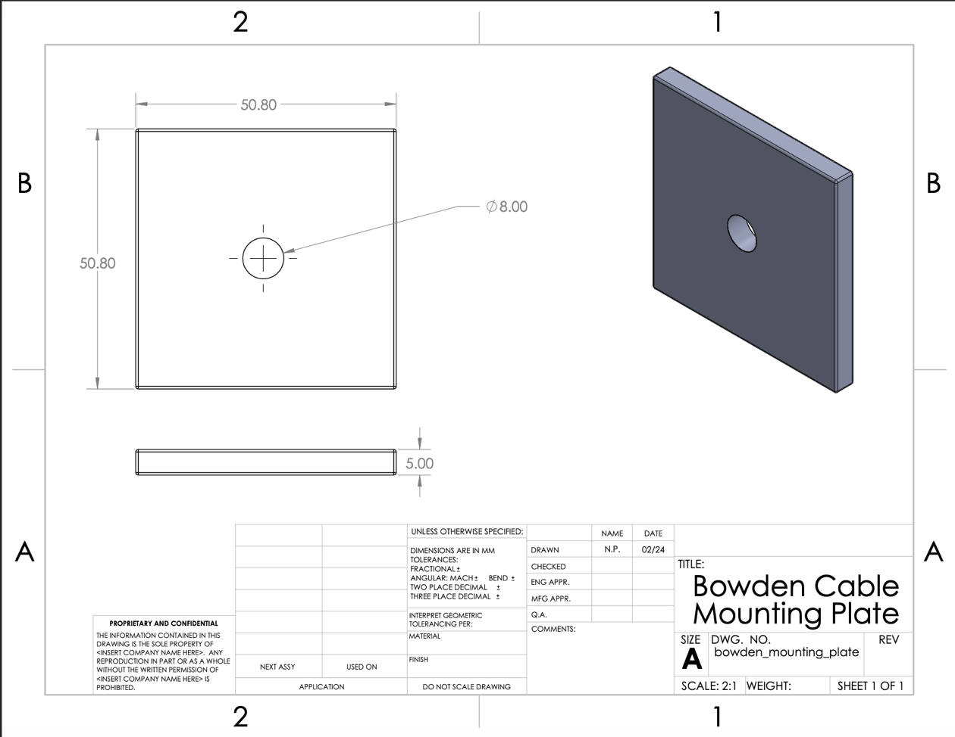
Figure 36: Bowden Cable Mounting Plate
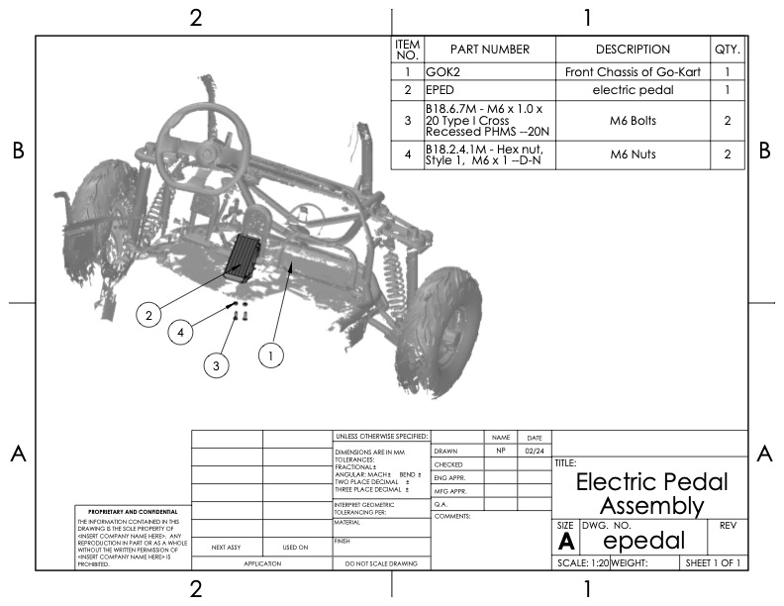
Figure 37: Final Electric Pedal Assembly

